

Fresh Approach Collective Worship Planning
Year B - Term 1

Week 1 | New Beginnings
Week 2 | People of faith - Joshua
Week 3 | People of faith - Ruth
Week 4 | HARVEST (Please change the week to reflect your local church Harvest celebration)
Week 5 | People of faith - Samuel
Week 6 | Celebrating people whose faith helped to change the world.
Week 7 | Standing up for what you believe (can be linked to Black History Month)
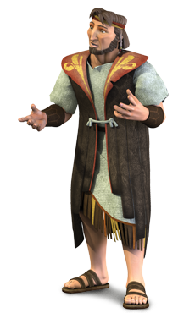
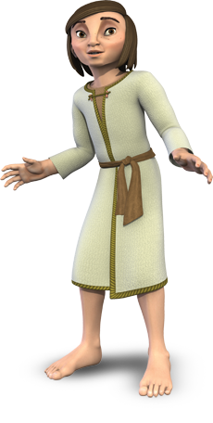
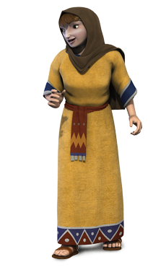
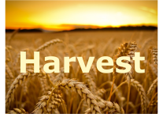
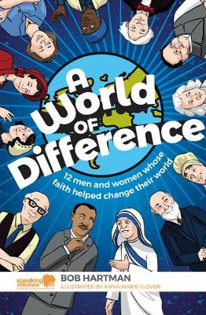
Additional Information for Teachers
A visual overview of the Old Testament books of Joshua, Ruth and Samuel can be found at:
https://thebibleproject.com/explore/joshua/
https://thebibleproject.com/explore/1-samuel/
https://thebibleproject.com/explore/ruth/

Freedom Week materials are taken from the Clewer Initiative https://www.theclewerinitiative.org/ working with https://www.modernslaveryeducation.com/

Liturgical colour | Monday  Whole School | Tuesday  Whole School | Wednesday  Whole School | Thursday  Worship in the classroom | Friday  Whole school Celebration worship
Week 1  New Beginnings | Happy New Year! New Beginnings.  Isaiah 43:18-19  This week will very much be individual to your own school context, a welcome back for children and staff. A time to share your school Christian vision and associated values. You may have a school prayer to introduce and learn.  Forget the former things;  do not dwell on the past.  See, I am doing a new thing!  I wonder what you think this Bible verse might mean. What should we forget and what will we be looking forward to?  Begin a reflective prayer space linked to New Beginnings. Encourage all members of the school community to use this space.  Some ideas for prayers can be found here  https://www.prayerscapes.com/prayers/occasions/prayer_for_new_beginnings.html  More Bible quotes for New Beginnings  https://www.openbible.info/topics/new_beginnings | New Beginnings – why are there rules?  Matthew 7:12  I wonder what this Bible verse means and why it is referred to as ‘the Golden Rule’.  The following links have ideas about rules and link with the Ten Commandments – please adapt these ideas so that they reflect your own school context and are incorporated into your own ways for collective worship  https://www.assemblies.org.uk/pri/545/rules-rule  https://www.assemblies.org.uk/pri/2452/respect-for-rules  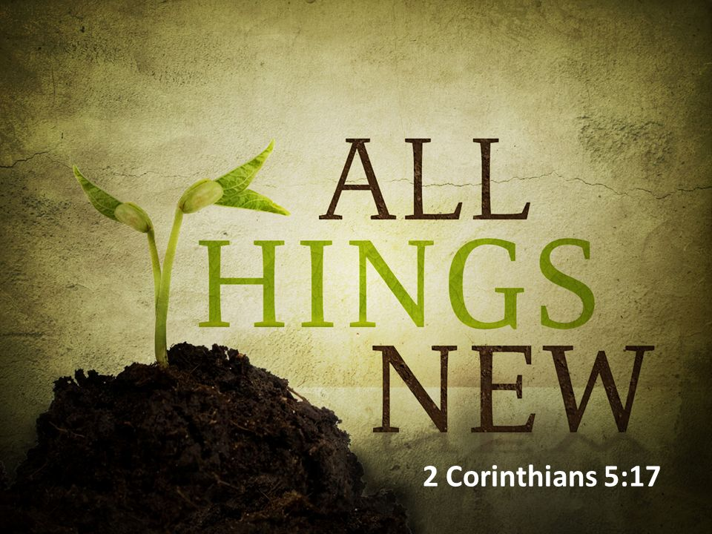  I wonder what rules we follow in our school. I wonder why we need these rules. I wonder if you think that these rules help us to love our neighbour as we love ourselves. How will you do that today? | New Beginnings – why do we worship by singing together?  Psalm 147:1  ‘Singing in schools dramatically improves self-esteem…helps children to be more calm and focused and increases enjoyment and engagement’ (CUREE 2015)  Talk about why you come together as a school every day for worship. Explain the importance of singing together. See Fresh Approach to planning and leading Collective Worship for more guidance.  I wonder if you sing a grace together in your school at lunch time. Perhaps you would like to learn a new one to use.  https://www.youtube.com/watch?v=5G_QZEQPylQ or similar    You might like to learn Brand New Day by Damian Herbert and Ready To Go by Luke Aylen from the Big Start Collective Worship CD.  Action song for younger pupils  https://www.youtube.com/watch?v=pEkeQcHX1LU  You might like to also begin listening to or learning Giants of Faith by Pete James for next week.  https://www.youtube.com/watch?v=2aM5DViPkqc | New Beginnings – what do we value?  I Thessalonians 5:14-18  I wonder if you can remember our school vision and values. I wonder if you see these put into action in our classroom, playground and school by the pupils and by the adults. I wonder if this Bible verse helps us to live together in positives ways too: Encourage anyone who feels left out; help all who are weak, and be patient with everyone… Be good to each other and to everyone else. Always be joyful and never stop praying.  Perhaps our vision, values and this Bible verse are about being a thoughtful person (see below)– reflect on all or some of these in an age-appropriate way:  A thoughtful person weighs up all the options before taking action; doesn’t usually rush into something carelessly; looks for creative ways to show kindness; takes time to work things out for themselves.  He or she isn’t superficial but thinks deeply about issues.  A thoughtful person uses his/her brain well – ‘uses their head’ and ‘looks before he or she leaps’.  A thoughtful person makes good connections between events and what people say; is interested in what others have to say; asks key questions in order to go deeper into issues such as:  I wonder how we can each do some of this today and as the year unfolds. | Celebration Worship  Think about the prayers that have been added to your prayer space about New Beginnings.  Use these during your worship.  Can you add any more this morning?  I wonder if anyone has seen others living out ‘The Golden Rule’ this week?  https://www.youtube.com/watch?v=485btt72V2o  – words to encourage us to follow Jesus’ loving example
Week 2  People of faith – Joshua | Joshua trusts God.  Joshua 1:1-9  Depending on when you will be holding your Harvest Service, the next few weeks will concentrate on three people with great faith in God from the Old Testament. These themes will look at the values of trust loyalty and faith.  I wonder what trust means to you. I wonder whom you trust and why. Demonstrate what trust might look like in school.  Moses led the Israelites slavery from Egypt, they wandered around in the desert waiting to enter into the land that God had promised them for 40 years.  This video clips sets the story of Joshua in context. The story for today looks at how Joshua became the leader of the Israelites. Joshua 1:1-9  https://www.youtube.com/watch?v=wUKWt46vubo  Check understanding of the story as there is a lot in the clip. Alternatively tell the story yourself using an appropriate version, focussing on how Moses and Joshua trusted in God even when things seemed too difficult.  I wonder where in the story Moses, Joshua and the Israelites trusted God?  I wonder if you think it was easy for Moses and Joshua to keep trusting in God, even after wandering in the desert for 40 years?  It can be hard to trust God, but I wonder if there is anything we might want to put our trust in God for  Strength! Courage! Don’t be timid; don’t get discouraged. God, your God, is with you every step you take.  Joshua 1:9 | Joshua leads the Israelites into the promised land.  Joshua chapters 3 and 4  I wonder what it feels like to you, to trust. I wonder what it feels like to you, to be trusted. Think, pair share  Joshua kept on listening to and trusting God.  This video clip tells the story of how, with God’s help, the Israelites crossed the Jordon River  https://www.youtube.com/watch?v=j5ifLZS0TTI up to 2 mins 30 secs  I wonder how Joshua felt when he arrived at the River Jordan  I wonder how the people felt when they saw the river?  I wonder how they felt when they stood in the dry river  I wonder why Joshua asked the people to take the stones and build an altar  Share Joshua 1:9 Have I not commanded you? Be strong and courageous. Do not be afraid; do not be discouraged, for the Lord your God will be with you wherever you go  God kept saying to Joshua that he must be brave and not worry because God would be with him wherever he goes.  Did you know … It says in the Bible 365 times ‘Do not worry’. That’s one for every day of the year!  I wonder how this promise makes you feel?  Sing or listen to Giants of Faith by Pete James  https://www.youtube.com/watch?v=2aM5DViPkqc | Where did Joshua place his trust?  Joshua 4: 4-7  I wonder if Joshua ever felt scared or worried as he was leading the people. I wonder if you ever feel scared or worried? Everyone feels anxious or worried sometimes, all adults and also children too.  Recap and act out the story from yesterday, especially Joshua Chapter 4, where the Israelites took the stones out of the river. Joshua 4: 4-7  So Joshua chose 1 man from each tribe. Then he called the 12 men together. ⁵ He said to them, “Go out into the river where the Ark of the Covenant of the Lord your God is. Each of you should find 1 large rock. There will be 1 rock for each tribe of Israel. Carry the rock on your shoulder. ⁶ They will be a sign among you. In the future your children will ask you, ‘What do these rocks mean?’ ⁷ Tell them the Lord stopped the water from flowing in the Jordan. When the Ark of the Covenant with the Lord crossed the river, the water was stopped. These rocks will help the Israelites remember this forever.”  I wonder why God told Joshua and the Israelites to collect these stones. (Remember how God took care of them and his promise to take them into the promised land, how the Israelites had finally put their trust in God.)  I wonder how having this stone reminder might help the Israelites in future times?  I wonder what other people do to remember all that God has done for them?  Have a time of reflection while you listen to Trust in You by Lauren Daigle  https://www.youtube.com/watch?v=qv-SXz_exKE  I wonder what God’s promise that you can trust will mean for you this week? | Joshua and the Battle of Jericho  Joshua 6: 1-21  I wonder what happened next to Joshua and the Israelites  Retell and act out the story of Joshua and the Battle of Jericho. This is a great example of how much the Israelites trusted in God as it was a fairly crazy thing for them to do. (Be aware that the story doesn’t end well for those inside the walls of Jericho, so you may want to censor the end of the story!)  You might like to role-play this story outside with speed stack cups as your walls of Jericho, or inside using dominoes!  https://www.youtube.com/watch?v=6AlIaJr1kds tells the story too  I wonder if you think that Joshua and the Israelites were strong and courageous. I wonder what was of most help to them?  Reflect on what learning about the story of Joshua has meant to you this week. Give the children a template of a stone or an actual stone to create a reminder like Joshua did in your classroom. The children could decorate them with the verse Joshua 1:9. I wonder how this story might help us to think about the part that trust plays in our lives?  Listen and learn the song Be Bold, Be strong! You might like to create some actions to go with this too.    https://www.youtube.com/watch?v=zRvCUz6KFB4 | Celebration Worship  Trust is like a piece of paper, once it’s crumpled, it can’t be perfect.  Demonstrate this using a piece of paper.  I wonder if you agree with this statement.  I wonder if people can trust you.  Who has shown that they can be trusted in school this week?
Week 3  People of faith – Ruth | Ruth – the loyal friend.  Ruth chapter 1  I wonder what does the word loyal means. I wonder if you can think of anyone who is loyal. (Think, pair, share)  I wonder if you a loyal friend.  This week we are going to be learning about a lady called Ruth. Her story is told in the book of Ruth. Show where this is in the Bible.  Retell or act out the story of Ruth and Naomi when they travel from Moab to Bethlehem, found in Ruth chapter 1. (Be aware the story speaks of Ruth and Naomi both being widowed)  ¹⁶ But Ruth said, “Don’t ask me to leave you! Don’t beg me not to follow you! Every place you go, I will go. Every place you live, I will live. Your people will be my people. Your God will be my God. ¹⁷ And where you die, I will die. And there I will be buried. I ask the Lord to punish me terribly if I do not keep this promise: Only death will separate us.” Ruth 1: 16-17  I wonder why Ruth chose to stay with Naomi rather than going home to her own people. I wonder how Ruth was a loyal friend to Naomi? I wonder what this story might teach us about Ruth and her belief in God?  I wonder if you are a loyal friend like Ruth? I wonder what you could do to be more loyal to your friends?  Ruth’s words to Naomi put to music in two different ways:  https://www.youtube.com/watch?v=4QnT323Gahg  https://www.youtube.com/watch?v=cfcROjHczLg | Supporting those who need it most  Ruth chapter 2  I wonder what you do to support your friends? I wonder if you would you go the extra mile for them.  I wonder what happens next to Ruth and Naomi? They have arrived back in Bethlehem without any money or anyone to care for them.  Retell the story from Ruth Chapter 2.  To make sure they had food to eat, Ruth went to work in the field collecting all the grain that was left over after harvest, this was really hard work. Boaz showed compassion to Ruth and asked his workers to leave extra grain for Naomi.  I wonder why Boaz did this. I wonder if he had to do this. I wonder if he did the right thing. I wonder what you would have done in this situation.  ¹¹ Boaz answered her, “I know about all the help you have given to Naomi, your mother-in-law. You helped her even after your husband died. You left your father and mother and your own country. You came to this nation where you did not know anyone. ¹² The Lord will reward you for all you have done. You will be paid in full by the Lord, the God of Israel. You have come to him as a little bird finds shelter under the wings of its mother.” Ruth 2 11-13  Sometimes we don’t know the impact of our kindness or kind words, but Ruth said that the kind words which Boaz said to her gave her hope. Ruth had been through a really tough time, but through Boaz’s love and compassion she felt she had hope.  I wonder who you could help and support and bring hope to today? | God rewards Ruth for her loyalty  Ruth chapter 3 and 4  Put up a picture of Ruth and Boaz – what have we learnt about them both so far? Describe their characters. Think, pair, share.  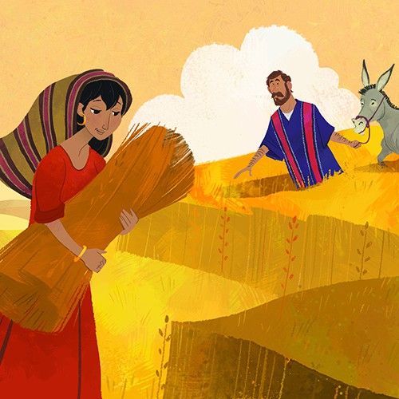  I wonder what happens next. Can anyone guess?  Ruth chapter 3 and 4 tells the story of what happens next. (It is quite complicated in places, so you will want to paraphrase it.)  https://www.youtube.com/watch?v=V0t2gWjZDug  tells the story of Ruth from the beginning to the end. It might help the children see the story as a whole.  I wonder how Boaz marrying Ruth made a difference to her and Naomi’s life.  I wonder how Ruth was rewarded for her loyalty to Naomi.  I wonder if Ruth did the right thing by staying with Naomi.  I wonder what you would have done.  Learn Faith as small as a mustard seed  https://www.youtube.com/watch?v=xECxevPcRBs | Ruth – a woman of faith  Ruth 1-4  https://www.youtube.com/watch?v=pyr3AyI7zVY is a summary of this week’s story of faith  Last week we looked at the book of Joshua – the story is really ‘big’ and dramatic with lots of people, the Jordan River parting and the walls of Jericho falling. In comparison the book of Ruth seems very ‘small’, about a widow and her daughter-in-law.  I wonder why Ruth’s story is important. Think, pair, share  I wonder what we might learn from the story of Ruth.  Focus on friendship  I wonder if you are a loyal friend.  I wonder how you would go the extra mile for someone you care for.  I wonder how we could support those who need our help?  I wonder if I show enough compassion and kindness to others through my words and actions   | Celebration Worship  Celebrate examples of loyal friendship in school this week, shown by both pupils and adults.  https://www.youtube.com/watch?v=cNIg45GZ_ts  This version of the well-known song could help you to focus on the words rather than on ‘Toy Story’
Week 4  See the Global Neighbours handbook for more information and guidance on being a courageous advocate and raising the profile of global issues of poverty and inequality. https://www.christianaid.org.uk/sites/default/files/2018-03/Global-Neighbours-Accreditation-Scheme-Handbook-January-2018.pdf  To explore this theme further explore the Christian Aid prayer spaces https://www.prayerspacesinschools.com  HARVEST | Why do we celebrate Harvest?  Matthew 9:38  Ask the Lord of the harvest, therefore, to send out workers into his harvest field. Matthew 9:38  This week will be individual to your school context. It might reflect the charity which you choose to support and build towards your own Harvest Service. Check if your local church is celebrating Harvest on a different week and adjust accordingly so that it can be a whole community celebration.  You might like to also like to look at the following ideas:  https://www.salvationist.org.uk/resources/schools/seasonal-assemblies-primary  https://www.eauk.org/church/resources/harvest.cfm (archive) | How can we share our harvest?  Deuteronomy 24:19  When you gather your crops and fail to bring in some of the grain that you have cut, do not go back for it; it is to be left for the foreigners, orphans, and widows, so that the LORD your God will bless you in everything you do.  Deuteronomy 24:19  Recall the story of Ruth from last week. Boaz was following this command from scripture to leave some grain in the fields for foreigners, orphans and widows. Because Boaz did this, Ruth and Naomi were able to eat.  https://www.brf.org.uk/product/ruths-harvest-surprise/  I wonder how this idea, of leaving some food for others, could work now? Perhaps next time you are in the supermarket you could look for a box or a trolley that people can pop food donations into after they shop. It is often behind the tills or on the way out…I wonder if you’ve seen this. Find out about your local foodbank and where you can donate all year round near you.   | How can we say thank you for our harvest?  Psalm 104  I wonder what Christians do to show their gratitude for the harvest each year.  https://www.youtube.com/watch?v=xlBkpAm3fhw  Listen and look at the words of the traditional hymn ‘For the Beauty of the Earth’ This is a beautiful hymn of thanks. It was written by Folliot Sandford Pierpoint, an English school master, in 1864.  I wonder why he wrote these words. I wonder what it shows about how he was feeling about God and the world. I wonder how this song and the words makes you feel. I wonder which words stand out to you the most.  Psalm 104 is a hymn of praise about God’s creation, written by King David. These verses are part of a longer passage where David expresses his gratitude for all the things God does through his creation. (You may want to draw out other verses to explore with the children)  I wonder how this verse may encourage our farmers and all those who grow our food for us  ‘He makes grass grow for the cattle,  and plants for people to cultivate—  bringing forth food from the earth’  Psalm 104: 14  Reflect on the amazing work all the farmers do to ensure we have food to eat and saying thank you for their hard work in producing our harvest. | God’s gift of creation – do we use it wisely?  Isaiah 5:1-2  https://www.brf.org.uk/product/harvest-isaiah-pictures-a-vineyard/  This is a lovely reflective story presentation looking at the parable found in Isaiah 5:1-2. The link above contains thoughtful and reflective questions within the story for the children to discuss.  The parable talks about a man who planted a vineyard on a fertile hill, who worked hard to prepare the soil and land so the vines would produce good grapes. Unfortunately they grew sour wild grapes that tasted horrible.  (The prophet uses this story about the planting of a vineyard as a way of speaking about God's gift of creation to his people and God's hope that their lives would produce good fruit. God wants them to wake up and be people whose lives produce the fruit of thankfulness and goodness in response to his great love for them. Sadly, his people's lives had instead proved a bad harvest of rotten grapes.)  Invite the children to write prayers of thanks for the harvest and for creation that they could share as part of the Harvest service, or to place in a reflective prayer space to be enjoyed by all.  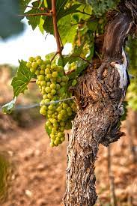 | Harvest Celebration Worship  It might be today or on another day this week that you hold your school celebration for Harvest  .  https://www.youtube.com/watch?v=Njkm9jEW7cc
Week 5  People of faith – Samuel | Keep on praying – have faith in God Hannah’s story  1 Samuel 1  I wonder in what ways Joshua and Ruth were people of faith.  This week we are going to be learning about Hannah and Samuel –  Share where the story of Samuel can be found in the Bible.  Today we are going to meet Hannah. She had a great faith in God and spent a long time praying that God would give her a baby.  Share Hannah’s story from an appropriate Bible or watch:  https://www.youtube.com/watch?v=hVBZO4YEtbg  Think, pair, share…  I wonder how Hannah felt when she was praying in the temple for a baby.  I wonder how Hannah felt when God answered her prayers.  Sometimes we have to wait for God’s timing as he tells his people his timings are best. This can be hard especially if you have to wait for a long time.  I wonder how Hannah was a person of faith. I wonder how her faith helped her to get through difficult times.  Christians believe that it is important to pray and wait to see how God will answer their prayers. They believe that God will do this as part of his bigger plan for his people.  The words of this Christian song express the hope that Christians have as they with upon God  https://www.youtube.com/watch?v=f2us61f-4Ak | Listening to God  Samuel’s story  1 Samuel 3  ‘The LORD came and stood there, calling as at the other times, "Samuel! Samuel!" Then Samuel said, "Speak, for your servant is listening."  1 Samuel 3:10  I wonder if it is important to listen.  Think, pair, share  Using props, demonstrate how difficult it can be to listen carefully, especially when there are lots of other voices or things in the way. I wonder what sorts of things can get in the way of being able to listen.  Think, pair, share  Act out the story of  1 Samuel 3 from an appropriate Bible or watch:  https://www.youtube.com/watch?v=7yLEGzWIpVc  I wonder how Samuel must have felt to hear from God at such a young age.  Samuel had to listen carefully to God as God had a special message he wanted him to share with Eli. As Samuel grew up, God continued to speak through him and all of Israel listened to him.  I wonder if you find it easy to listen to important messages given to you  I wonder how you can be more like Samuel and listen really carefully to the right voices. | Listening to God in the silence  Psalm 46:10  Listen to Be still for the presence of the Lord  https://www.youtube.com/watch?v=ZugvUQ4m90U  Have the word LISTEN one letter per page. Ask the children to move the letters around to form a new word, SILENT.  I wonder how we can listen if we are not silent.  I wonder if silence is helpful for you.  Hannah prayed silently to God. She prayed in her heart. Samuel heard the voice of God when he was silently asleep.  God speaks in the silence of the heart. Listening is the beginning of prayer.  Mother Theresa  I wonder what you think that this means  I wonder whether you agree with this statement  Have a time of stillness, silent reflection and prayer. Allow the children time to think about things that might want God to help them with, like Hannah did.  With younger children it can help to have some images to focus on such as a candle flame or water.  You might like to listen to Be still my heart and know by Hillsong  https://www.youtube.com/watch?v=4zcHHp0GTuc  or Be still and know that I am God  https://www.youtube.com/watch?v=AyDr9-Mpc_s | Being a giant of faith  Hebrews 11:1  Matthew 17:20-21  I wonder what it means to be a giant of faith. I wonder what it means to have faith.  The song ‘Giant of Faith’ talks about people in the Old Testament being ‘giants of faith’ – I wonder what you think this means.  https://www.youtube.com/watch?v=2aM5DViPkqc  I wonder how Joshua, Ruth, Hannah and Samuel were giants of faith. I wonder if you can think of 10 ways in which God their faith was rewarded by God.  I wonder if you have learned something new about faith over the past few weeks. I wonder how you might be a giant of faith. I wonder if God could help you to be strong when you face challenges.  Thank God for the stories of Joshua, Ruth, Hannah and Samuel and invite pupils and staff to ask God to help them to face challenges when they come thier way.  With older pupils, you might consider how Hebrews 11:1 might help us to understand what ‘faith’ means. | Celebration Worship  Think about who has listened well this week. I wonder why this has been important and helpful.  One must talk little and listen much.  (African proverb)
Week 6  Men and women whose faith helped to change the world | Making a difference in the world  This week in worship we are going to be focusing on people whose faith in God have helped to change the world today.  The stories for this week can all be found in this book, alternatively look for alternative versions of their stories or for other individuals that you feel have a relevance for your particular context.  You can buy this book here.  Being generous  George Cadbury  Romans 12:11-13  (Page 13- 20)  I wonder how George Cadbury used his faith to change the world. I wonder what was mor important to him - producing chocolate or following the example of Jesus and take care of those who needed the most help?  I wonder what difference George made to those who worked for him.  https://yourstory.com/2016/09/story-of-george-cadbury  Romans 12:11-13 (NLT)  Never be lazy, but work hard and serve the Lord enthusiastically. Rejoice in our confident hope. Be patient in trouble, and keep on praying. When God’s people are in need, be ready to help them. Always be eager to practice hospitality.  I wonder if you think that this Bible verse might have encouraged George Cadbury? | Being a peacemaker  Martin Luther King Jr  Romans 12:17-18  (page 71-76)  This assembly outline can support the teaching and understanding of this story.  https://www.assemblies.org.uk/pri/3009/the-life-of-martin-luther-king  I wonder how Martin Luther King helped to change the world. I wonder how this faith helped him. I wonder how Martin Luther King followed the example Jesus set in this Bible verse.  ‘If someone does wrong to you, do not pay him back by doing wrong to him. Try to do what everyone thinks is right. ¹⁸ Do your best to live in peace with everyone.’  Romans 12: 17-18  I wonder what you might learn from the example of Martin Luther King Jr. I wonder how you try to live in peace with everyone?  Prayer of St. Francis of Assisi  Lord, make me an instrument of your peace. Where there is hatred, let me sow love; where there is injury, pardon; where there is error, the truth; where there is doubt, the faith; where there is despair, hope; where there is darkness, light; and where there is sadness, joy. O Divine Master, Grant that I may not so much seek to be consoled, as to console; to be understood, as to understand; to be loved as to love. For it is in giving that we receive; it is in pardoning that we are pardoned; and it is in dying that we are born to eternal life. Amen.  Sung version of this prayer  https://www.youtube.com/watch?v=ihhvm6eLWZI | Fighting for freedom  Harriet Tubman  Isaiah 1:17  (page 21-28)  You might like to learn to sing Stand up for what you believe in By Doug Horley  https://bigstartassemblies.org/songs/stand-up/  Harriet used her faith in God and her knowledge of Bible stories to encourage her and inspire her to stand up for freedom of all the slaves.  ‘Learn to do right; seek justice.  Defend the oppressed.  Take up the cause of the fatherless;  plead the case of the widow.’  Isaiah 1:17  I wonder what you might learn from these Bible verses. I wonder how they might inspire you into action like Harriet.  Harriet was compared to Moses, I wonder why you think this was the case.  I expect Harriet was very scared of being caught when she was working on the underground railroad, but like Moses she knew that God was walking with her to guide, support and protect her. God promises the same for everyone when people to ask him for his help.  Dear God, Thank you for all the promises in the Bible that say we should not be afraid because you hear us when we ask for your help. Thank you for being there for us when we need you and when we call on you. Amen | Seeing a need – and doing something about it!  Cecil Jackson – Cole  I John 3:17  (page 85-91)  You may not have heard of Cecil Jackson – Cole, but he was the man who started Oxfam charity shops – I wonder what we can learn from his story.  I wonder what stories or examples from the life of Jesus might have made Cecil think about what he should do with his life.  I wonder how this Bible verse might have inspired him.  ‘If anyone has material possessions and sees a brother or sister in need but has no pity on them, how can the love of God be in that person? Dear children, let us not love with words or speech but with actions and in truth.’ 1 John 3:17  I wonder what this Bible verse might say to you about your life. I wonder where you could help or support others like Cecil did.  https://www.oxfam.org.uk/oxfam-in-action/impact-stories/  You might want to look at some examples of Oxfam’s work today – make sure that you do not re-inforce any stereotypes when choosing the examples to use in your context. | Celebration Worship  Celebrate examples of individuals who have made a difference in your school this week.  Remember that each small difference is important  https://eventsforchange.wordpress.com/2011/06/05/the-starfish-story-one-step-towards-changing-the-world/
Week 7  Standing up for what you believe | GIVING THE RIGHT MESSAGE EVEN WHEN PEOPLE DO NOT WANT TO LISTEN  The people of faith and the people that made a difference that we have looked at so far this term have been people who have had to be prepared to stand up for what they believe. That is not too difficult if people stand with you and beside you but is not so easy when you find yourself standing alone and speaking alone.  In the Old Testament, the prophets were the people whom God sent to give his message. Very often they found that people did not want to listen or laughed at them or even attacked them.  Jonah  The book of Jonah  Sometimes the prophet that God calls know that the job of giving the message from God would be unpopular and so tried to run away and avoid the job.  Share the story of Jonah  https://www.youtube.com/watch?v=WOSadLyqshg  https://www.freebibleimages.org/illustrations/jonah-disobeys/  Make sure that pupils understand that the Jonah was a prophet and that his message that people should stop doing things that were wrong in God’s sight is at the heart of the story.  I wonder if you have ever seen anything that you know was wrong and spoken up. I wonder if that was easy. I wonder if it is sometimes easier to pretend you did not see it and go the other way as Jonah did. That is a very natural way to feel but it can help someone in a difficult situation to have courage and speak out for them.  Dear God, Give me the wisdom to see when something that is happening is not right. Give me the courage to act and the right words to say to help in such situations. Amen | DOING THE RIGHT THING EVEN WHEN IT PUTS YOU AT RISK  Daniel 6  I wonder if you have ever carried on doing something even when everyone else decided to do something else. I wonder if you have ever done what is easiest because it causes less trouble than disagreeing with the crowd.  In today’s story, someone broke the rules when everyone else was obeying them, because he believed that was the way that God wanted him to behave:  https://www.youtube.com/watch?v=I8tXENptCSo  https://www.freebibleimages.org/illustrations/yo-daniel/  The prophet Daniel showed the way to obey God in the most terrifying of circumstances and he changed the mind of a powerful ruler.  I wonder if there are any situations in the world today where people are standing up for justice by opposing those in power. I wonder how brave you need to be in such situations.  Dear God, please give me strength when I am weak, love when I feel forsaken, courage when I am afraid, wisdom when I feel foolish, comfort when I am alone, hope when I feel rejected, and peace when I am in turmoil. Amen. | Rosa Parks  Psalm 106:3  I wonder what the Bible verse says about God and justice.  I wonder if there are times when you feel that situations are unjust. They might be situations in school, locally, nationally or globally. I wonder what the injustices are.  https://www.christianity.com/church/church-history/church-history-for-kids/rosa-parks-and-the-bus-ride-that-changed-america-11635083.html  https://www.assemblies.org.uk/sec/1181/racism-the-rosa-parks-story  https://www.barnabasinschools.org.uk/idea/breaking-rules  I wonder why Rosa thought it was ok to break the rules in this case. I wonder how brave she had to be I wonder if there are any times when it can be acceptable to go against the rules.  Dear God, you know that change starts with the heart; please open the hearts of many so that we may see people the way you see people -- that we may love people the way you love people. Help us to acknowledge wrongs, give us clear minds and hearts to decipher the truth behind injustice. May we look at every circumstance through your lens of truth, love, grace, and mercy.  Amen  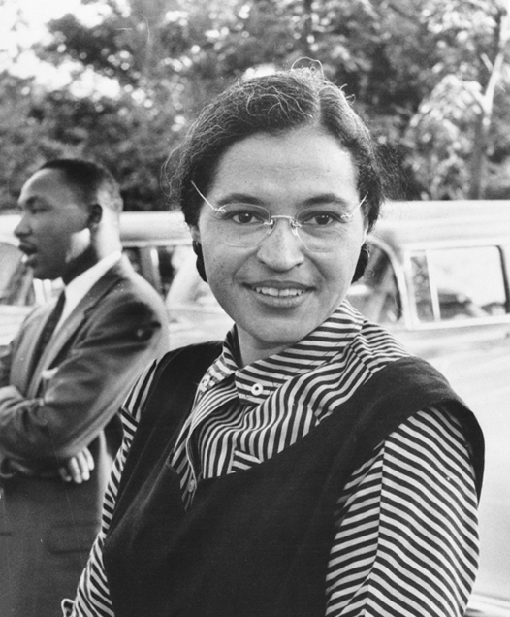 | Nelson Mandela  Matthew 5:10  https://www.assemblies.org.uk/pri/1995/mandela  https://www.christianaid.org.uk/resources/nelson-mandela-assembly-english  https://www.assemblies.org.uk/pri/1864/long-walk-to-freedom  https://www.assemblies.org.uk/pri/1995/mandela  Here are some things that Nelson Mandela said during his lifetime. I wonder if they help us to understand how important it is to keep persevering even in the face of injustice or apparent failure:  "A winner is a dreamer who never gives up."  "Education is the most powerful weapon which you can use to change the world."  "Do not judge me by my successes, judge me by how many times I fell down and got back up again."  "The brave man is not he who does not feel afraid, but he who conquers that fear."  Dear God, Today we remember and thank you for all who struggle and suffer for justice and freedom and for those who inspire and help us to realise our goals. Amen  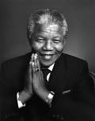 | Celebration Worship  Wish each other well for the holiday ahead:  May the road rise up to meet you. May the wind be always at your back. May the sun shine warm upon your face; the rains fall soft upon your fields and until we meet again, may God hold you in the palm of His hand.

Joshua Ruth Samuel

