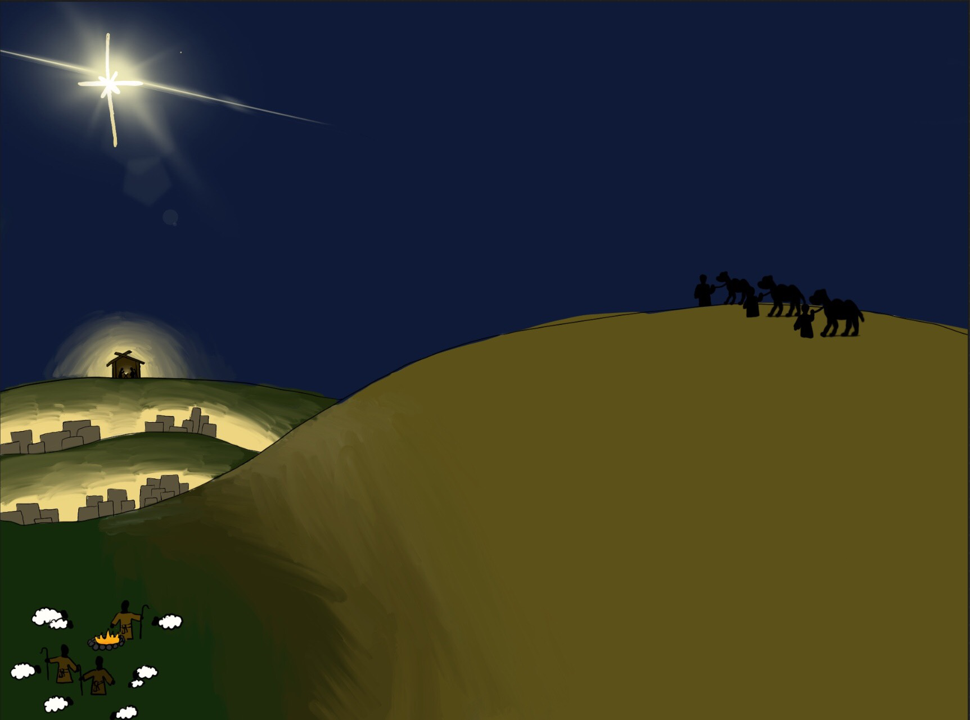

Fresh Approach Collective Worship Planning
Year B Term 2
Advent and Christmas

Week 1 | Take it back to the playground 1
Week 2 | Take it back to the playground 2
Week 3 | Remembrance Sunday, Anti bullying week, Children in Need
Week 4 | Take it back to the playground 3
Week 5 | Take it back to the playground 4
Week 6 | Advent
Week 7 | Advent
Week 8 | Christmas


This Advent, Lord, come to the manger of my heart.
Fill me with Your presence from the very start.
As I prepare for the holidays and gifts to be given,
Remind me of the gift You gave when You sent Your Son from Heaven.

© Annika Swansbury – images used with permission
Advent Christmas
Liturgical colour | Monday  Whole School | Tuesday  Whole School | Wednesday  Whole School  Psalm Praise / Singing Worship | Thursday  Worship in the classroom | Friday  Celebration worship
Week 6  Advent | Advent – Waiting  John 8:12  Discuss ‘to do’ lists, presents etc, including feelings about busyness and the pace of life (the image of a shaken-up glass of water with mud/silt in is really effective to discuss these feelings). Contrast this with the peace of lighting a candle  I wonder what we wait for. I wonder if these times are worth the wait.  Advent is a time of waiting for Christians – this can be related to the concept of Incarnation – waiting for God to come to the world as a human being, waiting for Jesus, the Light of the World to be sent to bring God’s light to this dark world.  As we prepare for Christmas, we can use the lights of Christmas to remember Jesus, the Light of the World.  Encourage a focus on thoughts about Jesus’s birth and the real meaning of Christmas singing or listening to a reflective song e.g. ‘v 1 of Be Still, for the presence of the Lord’  https://www.youtube.com/watch?v=ZugvUQ4m90U  This song has a focus on waiting:  https://www.youtube.com/watch?v=sp6OWxt2Rew  https://www.youtube.com/watch?v=7ePJJ5Yuw8c focuses on eager wait for Immanuel | Advent – a time for Listening!  Psalm 19:1-4  Light a candle, but this time a birthday cake candle. I wonder if you ever find yourself humming or singing when you are excited or happy - not just when you sing songs like ‘Happy Birthday’, but background singing as you live life.  Advent reminds us that Jesus is coming… amazing news, part of the plan of the Creator God and even nature can’t help but sing  Play some of the sounds/songs of nature:  https://www.youtube.com/watch?v=4KzFe50RQkQ (wind in trees) https://www.youtube.com/watch?v=HchoJcYNYlU (waterfalls)  https://www.youtube.com/watch?v=FvqqKvPhYF0 (windy mountains)  Read Psalm 19 v1-4, or watch a musical version e.g.  https://www.youtube.com/watch?v=_i4ONGfpmGk  The musician King David heard the music of nature and wrote this poem about it.  Read Isiah 44:23 - the prophet Isaiah said that Creation is singing not only to celebrate God the creator, but also the coming of the redeemer  Another song about what we can see in Creation:  https://www.youtube.com/watch?v=UEQahdqq-e4&list=PLVHu0Dxuc-sFDcV1SThlhk1XhAoze_wL0&index=12  I wonder if you can listen out for the songs of nature around you today. | Advent – a time for Looking!  Psalm 8  I wonder what we feel when we look at the world around us.  Use some of these examples of what we see and how we respond:  -cones/warning signs  -digital/billboard – anticipation  - traffic signs - careful  -school/home signs – safe  -hospital sign – helped  -balloons- excited  Show pictures of Windsor preparing for Royal Wedding with bunting, or London with Mall flags for Queen’s Platinum celebrations. What message is communicated?  Read Psalm 8  or watch as video clip:  https://www.youtube.com/watch?v=PHTqxAUETEQ or  https://www.youtube.com/watch?v=QEWV_xxf0P4  Seeing is a powerful sense.  For Christians, it helps them to see that Creation gives the message that God is good, that God created a perfect world and that God is in control and has a plan. As we mark Advent, we think of the part of that plan that brought Jesus into the world.  I wonder if you can take time today to see signs of God around you. | Advent – Waiting for God  Micah 2:2-5  Advent comes from the Latin word 'adventus' meaning 'Coming.' Advent begins the church year starting four Sundays before Christmas. The season of Advent has been set aside as a time of preparation since the 6th century. Advent is a time for preparing for Christ's second coming, even as Christians remember and celebrate his first coming at Christmas. This is why the colour of the season of Lent is used, purple, the colour also of Lent, of forgiveness and repentance.  https://www.youtube.com/watch?v=pj6vzfkk8II Use a traditional Advent hymn, ‘O come, O come, Emmanuel’, to think about how long God’s people had been waiting for God to help them and send the promised Messiah.  Read the Bible passage. This is a prophecy from God about the promised Messiah. It also explains that God’s people will be freed from slavery, when the baby (Jesus) is born. I wonder what the passage says to you about what the Messiah will be like. I wonder how important the name ‘Immanuel’ (God with us) might have been for those waiting for the Messiah to come? | Celebration Worship: The Best Gift Ever!  Open with song e.g. ‘Come on and Celebrate!’ https://www.youtube.com/watch?v=kog4QkDT4Ho  As we start our Christmas shopping, in wonder what are the best gifts we can give.  If you support a charity at Christmas, you could focus on this as a way of making sure that pupils understand the need to think about others who may need help with giving and receiving Christmas gifts.
Week 7  Advent | Light first Advent Candle – Hope  Remembering the Patriarchs – Those who have gone before us leading the way to Jesus.  Genesis 12:1-4  Introduce and explain the Advent wreath, which is decorated with five candles. These symbolise the passage of the four Sundays of Advent leading up to Christmas, with the 5th being lit on Christmas day.  The Biblical meaning of Patriarch –  any of those biblical figures regarded as ‘fathers’ of God’s people, especially Abraham, Isaac, and Jacob, and their descendants. The promise to the Patriarchs was originally given to Abraham. Read the passage – I wonder what you think that God’s promise meant.  I wonder why Christians remember the Patriarchs during Advent.  The key word for today is Hope – I wonder how the story of Abraham gives hope (God is faithful, walks beside Abraham, can be trusted, listens, guides, has a plan)  I wonder who your family unit* is built on I wonder who takes care, guides and walks with you through life.  Spend some time thinking about those people and then say thank you to God for all they have done to look after and love you.  (*Change the wording here or emphasise to suit the context of your school community.) | Light second Advent Candle – Faith  Remembering the prophecy of Isaiah, who foretold the coming of the Messiah. Isaiah 9:6  I wonder what the word prophecy means?  A prophecy is a message given to a prophet from God. In the Old Testament, there were lots of messages given to a prophet named Isaiah about the coming of the Messiah. (anointed one / promised deliver of the Jewish nation prophesied in the Hebrew scriptures)  Read the passage from Isaiah 9:6.  "For a child will be born to us, a son will be given to us; And the government will rest on His shoulders; And His name will be called Wonderful, Counsellor, The Mighty God, The Everlasting Father, The Prince of Peace.” Isaiah 9:6  I wonder what you think these words mean. Christians believe that this is a prophecy that came true when Jesus was born and began his ministry. Do you think this is an accurate description of Jesus? Which description do you like the most? Why?  Here is a song version of the Isaiah prophecy.  https://www.youtube.com/watch?v=kQmi_FSfJKc | Light third Advent Candle – Joy  Remembering John The Baptist  Luke 1: 5-25  As you light the candle ask the children what they think of when you say the word joy? I wonder where we might see joy in our story today? I wonder if you know anything about John, the cousin of Jesus? (Think, pair, share)  Tell the story of when an Angel told Zechariah that his wife Elizabeth was going to have a baby, even though they were very old and thought they couldn’t have children.  https://www.youtube.com/watch?v=Zb9OUWE_iIE  Look carefully at verses 12-17. I wonder what we learn about John from these verses. (John was later referred to as John the Baptist and was the cousin of Jesus). I wonder how Zechariah felt when he heard all these things about the child he was to have.  In Luke 1:39-45, we read about the joy of the meeting between Elizabeth and Mary, both of whom would have sons (John and Jesus).  I wonder where you see most joy in the Christmas story. I wonder what will give you joy today. | Remembering John The Baptist  Mark 1: 1-8  John the Baptist  I wonder why Christians remember John the Baptist at Christmas time? Recap the story about the birth of John the Baptist.  I wonder how john the Baptist fits into the Big Story of the Bible. This clip helps to explain that.  https://www.youtube.com/watch?v=cROnNgHCYQw You might like to watch this video to enable the children to complete the story of John the Baptist.  John had an important job to do on earth, he had to prepare people for the arrival of Jesus and start spreading the message of God’s love to prepare for the Gospel which Jesus came to bring.  I wonder what jobs God has called other people to do. I wonder how we can help to share the message of God’s love as John and Jesus did in their different ways. | Celebration Worship  Open with children reading some ‘rejoice’ texts such as  Psalm 9v2  Psalm 13v5  to remind that Advent is a time of great joy as we wait for Christmas.  Share the joys of the week with each other.
Week 8  Christmas | Light fourth Advent Candle – Love Remembering Mary, the mother of Jesus.  Luke 1:26-38  Ask some children to read or act the conversation between Mary and the Angel out.  “I am the Lord’s servant,” Mary answered. “May your word to me be fulfilled.” Then the angel left her.  Mary was very obedient to God’s message. I wonder how you would have responded. I wonder how she felt at this point.  Watch the Angel Gabriel visits Mary video clip  https://www.youtube.com/watch?v=LUHFX87OyDI  or tell the story in a different way.  There are many famous paintings depicting the Annunciation (visit of Angel Gabriel).  I wonder how Mary felt about being given the amazing gift of carrying the son of God  The fourth candle on the advent wreath is to remember Mary, but also to remember love. I wonder how these two might be linked. I wonder what you would do if someone asked you to do something really important and special.  Traditional carol:  https://www.youtube.com/watch?v=dKIc8JvxGbU | Promise – Remembering the birth of Jesus  Luke 2:1-7  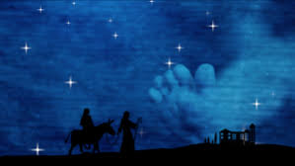  I wonder what you can see in this image. I wonder what it might represent.  Luke 2: 1-7 – The birth of Jesus  Read this section of the story – you could watch this video clip of the birth of Jesus.  https://www.youtube.com/watch?v=L5m2GE6DFeM  Explain to the children that the journey would have taken Mary and Joseph four or five days as Nazareth is 65 miles / 105 km north of Jerusalem, while Bethlehem is a hilltop town situated on a ridge near the edge of the Judaean desert, 5 miles / 8km south of Jerusalem. This would have been a hard journey as it would have been cold at night and Mary was heavily pregnant.  Spend some time reflecting on this journey and the faithfulness of Joseph as he cared for Mary along the way.  Hanna Varghese, God Is With Us, 2006.  https://thejesusquestion.org/2011/12/25/nativity-paintings-from-around-the-world/  Ponder on this image of Mary and Joseph with baby Jesus. I wonder why the artist painted it like this. I wonder why there are children sitting around Jesus.  John 1:14  The Word became flesh and blood,  and moved into the neighbourhood.  This verse reminds Christians that Christians believe that Jesus is God in human form, who came to live on earth with us to be with us. Emmanuel, God with us. | Peace – Remembering the Angels and Shepherds  Luke 2: 8-20  Today we are thinking about the angels and the shepherds.  https://www.youtube.com/watch?v=sGak3d7HOck  or told in your own way  I wonder how the shepherds felt when they saw the angels in the sky and heard them singing. They were afraid to begin with, but then they realised they had nothing to be afraid of.  Shepherds in Bible times were not highly thought of and were very unimportant. Many people avoided them as they thought they were smelly, dirty and not very clever. I wonder why you think that God chose shepherds to be the first people who knew of the birth of Jesus. I wonder  why they got the good news first.  (The good news that Jesus bought was for everyone, a life changing message of joy and hope. Jesus’s birth was not as anyone expected, born to a teenage mum, in a borrowed space away from home, visited by shepherds – this helps Christians today know that Jesus is one of them and understands life that is difficult and full of challenge).  https://www.youtube.com/watch?v=DE7_VtGIR8o  Angels by Matt Redman  Listen to this song as you reflect on the message the Angels brought to the Shepherds.  Or you could use this song – a modern version of The First Nowell  https://www.youtube.com/watch?v=vWaQFcvrDQA&list=PL1ILLIOB-HfHqkMRCQedfEHWMJYpolEnP&index=6 | Adoration – Remembering the Wise Men  Matthew 2: 1-14  I wonder what you adore. What does adore actually mean? (love and respect deeply) I wonder if you would travel large distancesor what you adore.  Unbelievably, a man in Manchester ordered a curry from a take away restaurant in New Zealand. The curry travelled 18830km!  https://guinnessworldrecords.com/world-records/76077-longest-curry-delivery  The wise men travelled about 800 miles from Persia to Bethlehem. This is a very long way following a star to find the promised Messiah. When they arrived they bowed down and worshipped Jesus, giving gifts.  Retell this part or watch this short clip  https://www.youtube.com/watch?v=22SMUUMsx0o  I wonder how the wise men felt when they saw the child Jesus. They had waited a long time to worship him.  I wonder how Mary must have felt when the wise men came to adore her child.  The wise men bought gifts for Jesus that symbolised his future.  The three gifts had a spiritual meaning: gold as a symbol of kingship on earth, frankincense (an incense) as a symbol of deity, and myrrh (an embalming oil) as a symbol of death.  I wonder if you were to visit Jesus what you would bring.  https://www.youtube.com/watch?v=tOhro_Y65Rs  What can I give him? Poor as I am  If I were a shepherd, I would give a lamb  If I were a wise man, I would do my part  But what I can I give him, Give my heart | Christmas Celebration worship  Light fifth Advent Candle – Light of the world  Reflect on the story and what the birth of Jesus means for Christians today.  This song expresses this:  https://www.youtube.com/watch?v=vYsR49ReAj4  I wonder what Christmas might mean for you.

