Fresh Approach Collective Worship Planning
Year B Term 3
The life of Jesus

Week 1 | Epiphany (Incarnation)
Week 2 | Jesus’ childhood – Jesus grew up (Incarnation/Gospel)
Week 3 | Preparation for ministry (Gospel/Kingdom of God)
Week 4 | Purpose: why did Jesus come? (Gospel/Kingdom of God)
Week 5 | Jesus heals – different types of healing (Gospel/Kingdom of God)
Week 6 | Teachings of Jesus (Gospel/Kingdom of God)
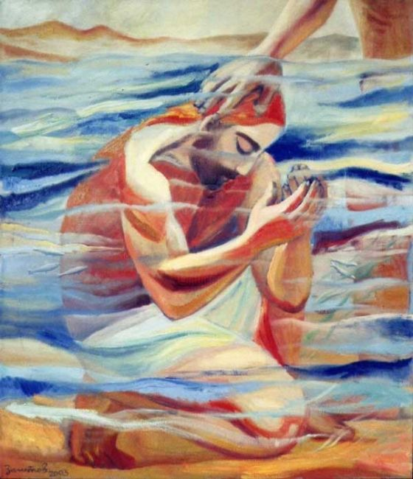
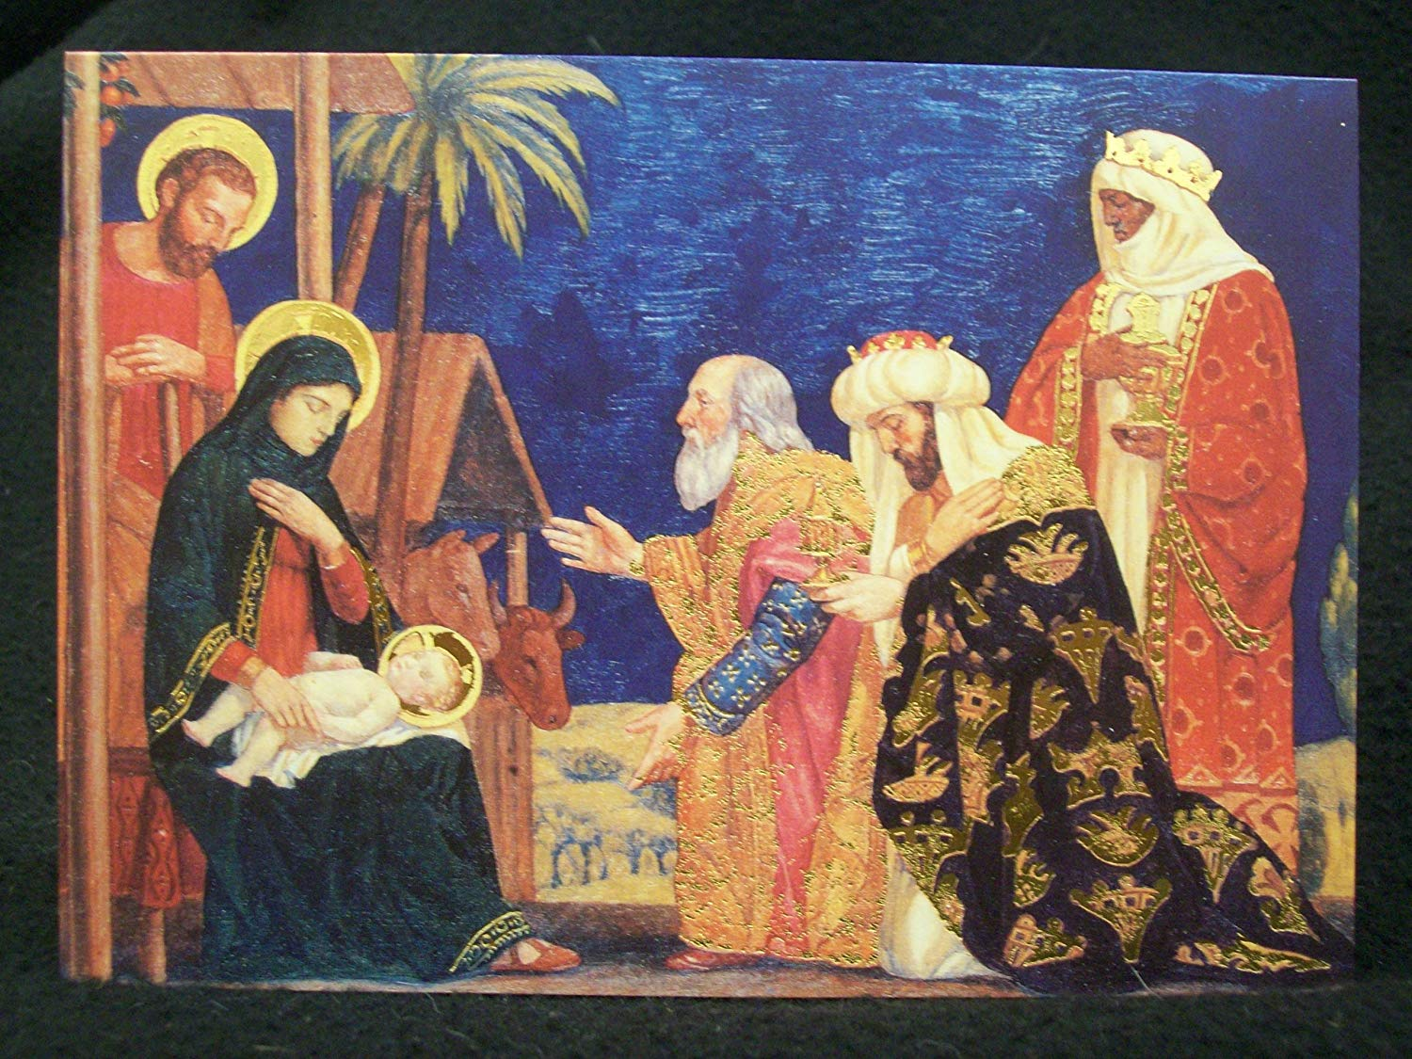

The life of Jesus
These plans are based on the stories taken from the ‘Gospel’ panel from the Understanding Christianity © Big Frieze.
The stories are taken from passages across the 4 gospels, Matthew, Mark, Luke and John and are in chronological order as far as possible. I hope that by exploring these stories through worship, everyone will have a better understanding of the Gospel message that Jesus brought when he came to earth as God in human form (Incarnation)
Term 3, looks at Jesus’ early life and how his ministry began.
Term 4, explores his ministry further and will lead us up to Easter.
The Life of Jesus - Gospel
Liturgical colour | Monday | Tuesday | Wednesday | Thursday | Friday
Week 1  Epiphany | Wise men visit Mary and Joseph  Matthew 2: 1-12  6th January is the celebration in the Christian calendar called Epiphany. This is when the Christian church remembers when the wise men came to visit Jesus.  The word 'Epiphany' comes from Greek and means 'manifestation'. It celebrates 'the revelation of God in his Son as human in Jesus Christ'. What other word do Christians use to describe God in human form as Jesus? Incarnation.  Retell the story of the wise men visiting Jesus from Matthew 2:1-12  https://www.youtube.com/watch?v=22SMUUMsx0o You could use this video clip.  Or use this or similar piece of artwork to discuss the what the children know about this story.  The wise men came from lands far away from Bethlehem, they did not worship the God of the Israelites, yet God chose them to bring worship and special gifts to Jesus which we will think more about in the next act of worship.  I wonder what important message the visit of the Magi (wise men) has for us. (God sent his son Jesus to Earth for everyone, not just the Israelites). | Gifts from the East – prophecy about who Jesus is.  Matthew 2: 11  I wonder if you like giving gifts to people Think back to a few weeks ago, how did it feel when someone opened a present you had bought or made for them?  When Jesus was still a baby, he was visited by some very special people, who brought him some unusual gifts. I wonder how Mary and Joseph felt when they arrived and presented Jesus with Gold, Frankincense and Myrrh  The gifts were symbolic of the importance of Jesus' birth, the gold representing his royal standing; frankincense his divine birth; and myrrh his mortality.  I wonder if you think that these are normal gifts to give to a baby.  I wonder what these gifts might tell us about who Jesus was going to be?  https://www.youtube.com/watch?v=JUcqVihFwos  You could watch this video from 1:14 – 3.20. This video shows a young girl explaining the meaning behind the 3 gifts.  I wonder what gifts we might offer to Jesus. | Mary and Joseph escape to Egypt  Matthew 2: 13- 16  ‘That night, Joseph got up and took his wife and child to Egypt.’ 2:14  Retell or explain to the children what happened when the Wise Men left Mary and Joseph.  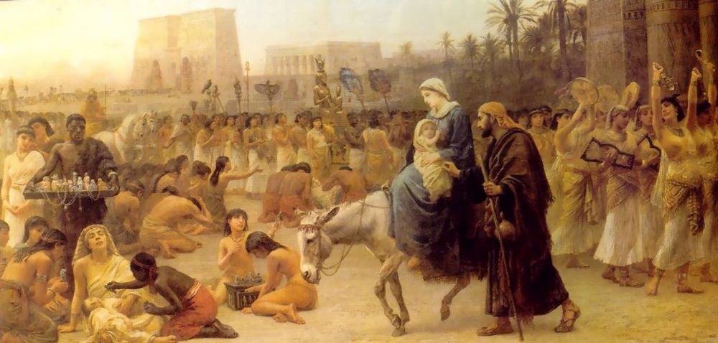  This picture shows Mary and Joseph entering into a land that was completely alien to them.  Give the children time to reflect on it, what do they notice about image. I wonder how Mary and Joseph felt entering and then living in a place so different to where they had come from. Share together.  It might well have been really hard, scary and difficult for them to get used to another culture and language.  Are there any similar situations in our world today?  If you have families who have had to flee their homes in your school be sensitive to their feelings when exploring this image and story. Change the reflection below to suit the context of your school.  Reflect on the millions of people across the world who have to leave their home and live in an alien place. What could we do as a community to support, love and include everyone? Pray together for all those who are working to support Refugees around the world and here in Britain. | Praying for refugees  Matthew 3:13-16  Mary and Joseph were welcomed as refugees into Egypt and lived there until the Angel told them it was safe to go home. Not everyone is as fortunate as this.  Prayer time – pray for those who have had to leave / are displaced or do not have a place to call home.    You could use this image by Khaled Hosseini (if appropriate) to focus on those who are having to take huge dangerous risks to get to a place of safety. Ask the children to discuss their feelings about this image and then invite them to write prayers for all those living in danger around the world.  Leviticus 19:33-34 The Voice (VOICE)  Share this passage together as part of your reflection time. What does the Bible tell Christians about how to treat those flee their homes and have to live somewhere else? Ask God to help everyone to try and follow this teaching.  You could use this prayer to close your time of prayer together.  Lord, make me an instrument of your peace  Where there is hatred, let me sow love  Where there is injury, pardon  Where there is doubt, faith  Where there is despair, hope  Where there is darkness, light  And where there is sadness, joy  Amen | Celebration Worship  You could use this as a time to celebrate the diversity of cultures within your school community and locality as appropriate.  Father God,  yours is a world made glorious by its rich diversity.  Give us the patience to build on what unites us, to celebrate our differences and to learn from them.  Give us the courage to offer refuge to those in need, to challenge prejudice and seek justice for all.  Help us see that you created us in your image. Neighbour or stranger, always our brother or sister.  Amen. (CAFOD)
Week 2  Jesus’ Childhood | Mary and Joseph present Jesus in the temple. Saying thank you for our families.  Luke 2: 21-24  Mary and Joseph took Jesus to the temple, which was part of their Jewish custom. They thanked God for their baby and offered a sacrifice of two doves in thanks to God for baby Jesus.  https://www.bbc.co.uk/programmes/p0114p1q  I wonder what your parents did when you were born. I wonder what they did to celebrate. Christians today thank God for their babies during the service of baptism or thanksgiving.  I wonder if you have thanked God for your family and siblings/cousins etc  Allow the children time to reflect on and think about their family, whatever it might look like, and all the things they are grateful for.  This Psalm is often used to pray a blessing over ourselves and those we love. Invite those in worship to say this psalm with together. They could replace the xxx with the words ‘my family’ or the actual name of someone in their family.  God ordered his angels to guard xxx wherever you go.  If they stumble, they’ll catch xxx;  their job is to keep you from falling.  Psalm 91 verses 11-12  Close your time of worship by inviting children and adults to say thank you prayers for those in their family, whatever this might look like. | Simeon meets Jesus  Blessing – Waiting for the Messiah  Luke 2: 25 - 35  There is a lot of waiting in the Christmas story – can you think of people who had to wait? God’s people had waited a long time for the promised Messiah, and then finally Jesus was born, but hardly anyone knew about him or who he was. When Mary and Joseph took baby Jesus to the Temple they met a man named Simeon.  https://www.youtube.com/watch?v=Mrhyc-Fbu_Y  Who was Simeon? Simeon was a man who followed God and was waiting for God’s promised Messiah to come to Earth.  The Bible tells us that as soon as Simeon saw the baby Jesus, he knew it was the promised Messiah.  I wonder how he knew.  This is quite a remarkable thing! There must have been something very special about Jesus for Simeon to know he was the Messiah.  I wonder what you think Simeon meant when he said:  ‘Your mighty power is a light for all nations, and it will bring honour to your people Israel.’ v33  Mary and Joseph were surprised at what Simeon said and amazed. I wonder how they felt when they heard all these things about their baby.  Simeon had waited a long time for the Messiah, but finally God had kept his promise. It isn’t easy to wait for things.  I wonder if you are waiting for anything. We can ask God to help us to be patient like Simeon and trust in God that he does hear our prayers for his help. | Anna meets Jesus  Luke 2: 36-40 – Praise God  The Bible explains that there was also a lady called Anna in the Temple, when Mary and Joseph met Simeon. Anna was a prophet and was a faithful servant of God. She spent most of her time in the Temple praying and fasting.  When she saw the baby Jesus, she praised God and told everyone about him and how he would set God’s people free.  Both Anna and Simeon were confident that Jesus was the Messiah – I wonder why and I wonder how they knew. I wonder what helped them to be so confident?  Anna and Simeon praised God when they had seen Jesus. I wonder what you might like to praise God for today. Think quietly about what you are thankful for.  Close in a thank you prayer together.  As you finish worship, read this passage together … this is what happened next …  Luke 2:39-40  After Joseph and Mary had done everything the Law of the Lord commands, they returned home to Nazareth in Galilee. The child Jesus grew. He became strong and wise and God blessed him.  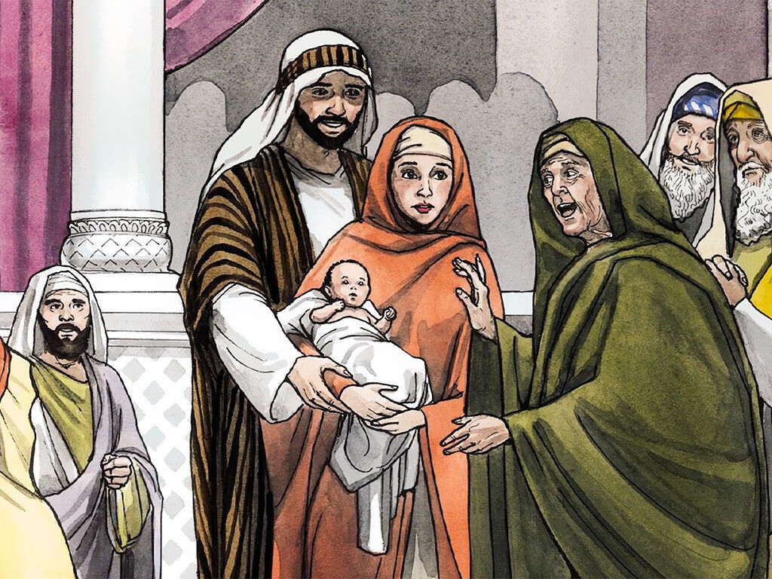 | Jesus in the temple – what does this tell us about Jesus?  Luke 2: 41-52  You could watch this video from 1.33 to the end. It tells the story of Jesus getting lost and being found in the temple.  https://www.youtube.com/watch?v=F2Z06a6VmW4  Try acting this story out with your class. I wonder how Mary and Joseph might have been feeling when they couldn’t find Jesus and then when they found him in the Temple?  v48 ‘ your father and I have bene very worried about you.’  I wonder why everyone was so surprised. Why do you think Jesus was so knowledgeable?  v47 ‘Everyone who heard him was surprised at how much he knew and the answers he gave.’  I wonder what Jesus meant when he said,  ‘Why did you have to look for me? Didn’t you know I would be in my Father’s house?  v52 Jesus became wise and he grew strong.  The Bible says that Jesus grew in wisdom and strength. Use this verse as a prayer – ask God to bless each child to grow as Jesus did, in wisdom and strength. | Celebration Worship  This week we have been learning about times in Jesus’ early life when God watched over Jesus, blessed him and helped him to grow.  Pray that this might be the case for us:  https://www.youtube.com/watch?v=gmylZ7Cy7Hs  The Lord bless you and keep you; The Lord make his face shine on you and be gracious to you; The Lord turn his face toward you and give you peace  (Numbers 6:24-26)
Week 3  Jesus prepares for his ministry | John the Baptist prepares the way – following the example of John  Luke 3: 1- 20  I wonder if you can remember one of the stories from before Christmas. We learnt about a man Zachariah and his wife Elizabeth. I wonder what you can remember of this story. (Luke 1:5-23)  Like Jesus, John grew up and began teaching people about God, so he could prepare the way for the coming Messiah.  https://www.youtube.com/watch?v=_OO84K9RuF0  This video clip clearly explains who John the Baptist was and the message he was sharing with people.  I wonder what job was givn to John by God and why people called him John the BAPTIST.  v11 John says … “If you have two coats, give one to someone who doesn’t have any. If you have food, share it with someone else.”  I wonder what this means and how this was similar to the ‘Good News’ that Jesus brought to the world.  I wonder how you could be like John. I wonder how we might share the good news message that John and then Jesus brought. Maybe through our actions?  Pray together – Ask God to help us to be generous and share what we have so that others will better understand the good news that Jesus brought. | Baptism of Jesus  Luke 3: 21-22  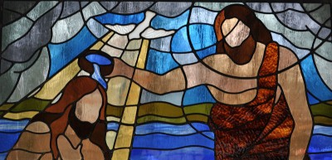  Look at these images together. I wonder what Bible story we are going to be looking at today. What strikes you in these images?  Read the passage of Jesus’ baptism together.  https://www.freebibleimages.org/illustrations/john-baptist-jesus/  I wonder what things in this story are amazing or unusual. I wonder why these things happened and what they tell us about Jesus. I wonder why Jesus wanted to get baptised. | Baptism of Jesus – saying sorry  Luke 3:21-22  https://www.youtube.com/watch?v=88JYcN2-FiQ  This video clip recaps the story of John and Jesus. You might like to do a mini quiz about what they know from the birth stories to the baptism of Jesus  Who has had a wash today or last night? Why did you do that? Why do we wash our clothes? Could we do these things without water?  Christians today, like they did in Bible times, believe that when they get baptised they become a new person, someone who has ‘washed’ away their old life and all the things that they have done wrong.  “Therefore, if anyone is in Christ, he is a new creation; the old has gone, the new has come!”  2 Corinthians 5:17  I wonder if there is anything you would like to say sorry for, something you would like to wash away. God promises that when we say sorry, he will ‘wash away’ all the things we are sorry for. You might like to take this metaphor of washing away things we have done wrong, by washing something dirty in front of the children.  You could listen to or sing this song together.  You forgive me by Lifetree kids.  https://www.youtube.com/watch?v=LO-2fm7IKcU | Jesus begins his work on Earth – sharing the good news (Gospel)  Luke 4: 16-22  Today’s story from the Bible explains what Jesus did when he first began his job of spreading God’s good news message. He went to the synagogue to read from the scriptures (The Torah). He read some passages from Isaiah, which are prophecies about the Messiah.  “The Spirit of the Lord is in me.  This is because God chose me to tell the Good News to the poor.  God sent me to tell the prisoners of sin that they are free, and to tell the blind that they can see again. Isaiah 61:1  God sent me to free those who have been treated unfairly, Isaiah 58:6  and to announce the time when the Lord will show kindness to his people.” Isaiah 61:2  I wonder why Jesus chose to read these passages out loud in front of all those who were listening. Jesus then said to all those who were listening “What you have just heard me read has come true today.”  I wonder what Jesus might have meant by this?  Christians have always tried to follow the example of Jesus by caring for those who most need help and kindness. I wonder how you might follow this example.  Look at the statements that Jesus made again – I wonder which example you might be able to do or follow.  You might like to listen to this song together  Help me be your eyes Lord Jesus by Doug Horley.  https://www.youtube.com/watch?v=UA0LEP3T1gQ  https://www.youtube.com/watch?v=N94BBGiq_vQ (with actions)  (Be aware it does include the line ‘Lord I love you’) | Celebration Worship  Celebrate those who have shown that they understand the example of Jesus in the context of school life:  God’s Spirit is on me; he’s chosen me to preach the Message of good news to the poor,  Sent me to announce pardon to prisoners and  recovery of sight to the blind,  To set the burdened and battered free, to announce, “This is God’s time to shine!”  (Luke 4 from The Message)
Week 4  See the Global Neighbours handbook for more information and guidance on being a courageous advocate and raising the profile of global issues of poverty and inequality. https://www.christianaid.org.uk/sites/default/files/2018-03/Global-Neighbours-Accreditation-Scheme-Handbook-January-2018.pdf  To explore this theme further explore the Christian Aid prayer spaces https://www.prayerspacesinschools.com  Purpose: Why did Jesus come? | Prophecy foretold – Jesus the light of the world  Matthew 4: 15-17  Today we are going to read another prophecy from Isaiah (we read one at the last week too). It is amazing that God was sharing the promise of the Messiah almost 700 years before Jesus was born!  Share verses 14-16 with the children;  ‘So God’s promise came true, just as the prophet Isaiah had said’ …  I wonder who this prophecy is pointing to, who is the bright light that will shine on everyone.  What is the bright light going to do? (Shine light into the darkness)  I wonder what the ‘darkness’ is.  I wonder how this makes you feel knowing that Jesus came to bring light, joy and hope into the ‘dark’ areas.  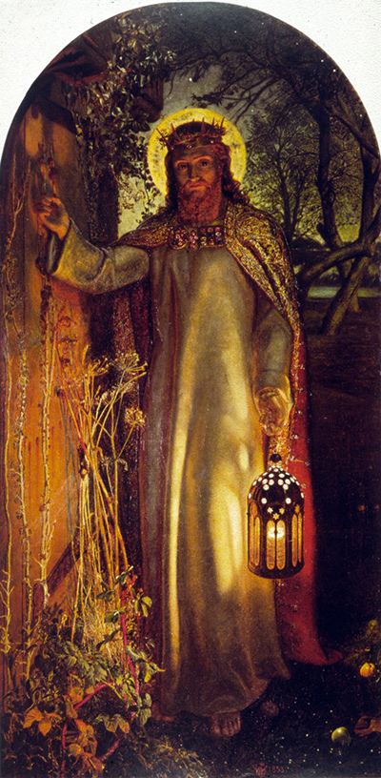  Spend some time reflecting on this image, Light of the World by William Holman Hunt.  I wonder what you can see/notice.  After some quiet reflection, pray together. Ask God to send his light and hope into the ‘dark’ places in our lives and the world. | Jesus calls the disciples – who do you follow?  Matthew 4: 18-22  https://www.youtube.com/watch?v=0VqTwnAuHws You could watch this video together. What does it show?  (A team working together to play something beautiful in an unconventional way.)  Working in a team is a great thing. Jesus knew that, so he had to get a team around him as he had a lot of work to do on earth.  I wonder what the word disciple means. This was the name given to those who followed Jesus.  https://thebricktestament.com/the_life_of_jesus/peter_andrew_james_and_john/mt04_22.html  Alternatively, gather some children to act out the story of Jesus calling his first disciples.  I wonder what amazes you about this story. (The fishermen just followed Jesus, they didn’t ask any questions …)  I wonder what you would ask Jesus and the disciples during and after this event had happened. I wonder what might have been so special about Jesus that they would want to follow him.  I wonder who you might follow and why?  Reflect on those you follow. Are they a good influence on your life?  Christians believe that Jesus is the best person to follow as he gave an excellent example of how to life a good life. I wonder what particular example of Jesus you might follow. | The miraculous catch of fish – follow the example of Jesus  Luke 5: 1-11  Who has been fishing? How easy is it?  What do you need to be a successful fisherman? (correct equipment, patience, water!). Today we are going to reading a story from the Bible about fishing.  https://www.youtube.com/watch?v=F120aeswBx0  I wonder what you think a miracle might be? Jesus performed many miracles, I wonder why. (To show the glory of God to those around, to help them understand more of the nature of God so they may feel they could put their trust and faith in him.) I wonder what this showed Peter about Jesus.  I wonder why Jesus performed this miracle.  I wonder what this story might teach you about Jesus. (suggestion: he provides what people need)  I wonder how you could follow the example Jesus set.  I wonder who could you help and provide for day by day.  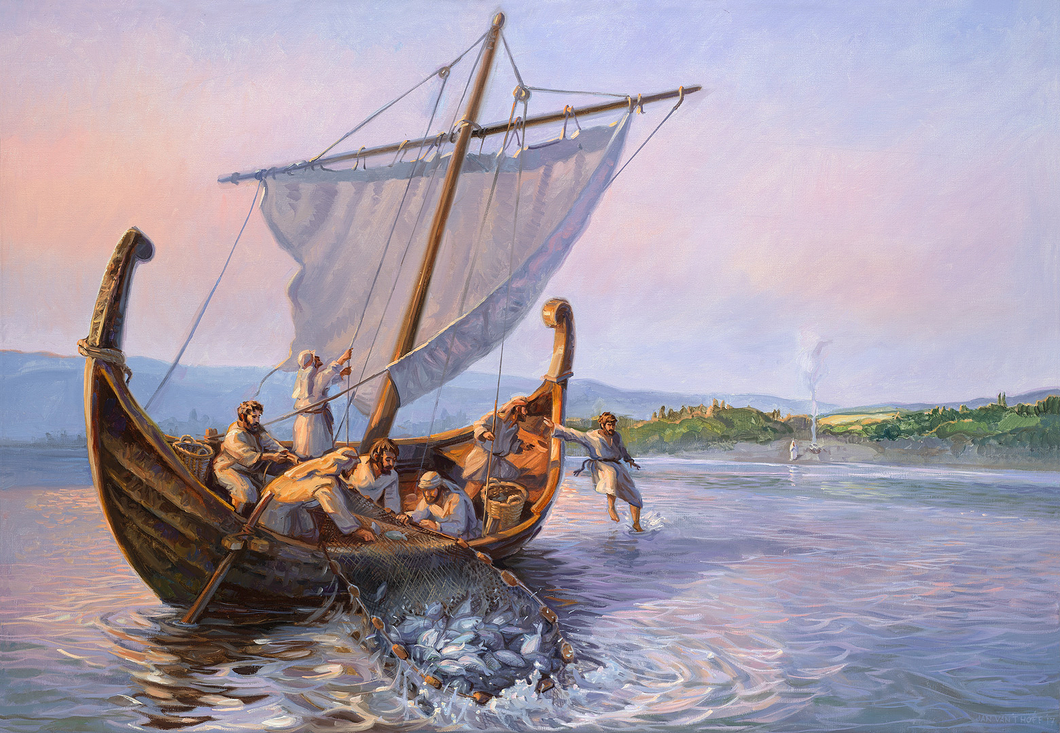 | Wedding at Cana – follow the example of Jesus  John: 1-11  Who has been to a wedding? What happened there? Jesus went to a wedding with his Mum and disciples.  Retell the story of the wedding at Cana and the miracle Jesus performed.  (Try illustrating the water turning into wine – have 2 jugs, a clear one filled with water and another jug you can’t see through with blackcurrant squash at the bottom. Then when you pour the water from one jug to another, it will turn into ‘wine’. Then pour the wine into an empty glass for the children to see.)  What was your reaction when the water turned into wine? I wonder what the bridegroom and his family thought when the best wine came out at the end of the wedding.  Why do you think Jesus performed this miracle? I wonder what this story tells you about Jesus? (Suggestions: Jesus was human just like us, went to weddings etc. Cared for people as it would have been very embarrassing for the family if the wine had run out. He provided what was needed)  This song expresses what Christians believe about the God that lived on earth as Jesus  https://www.youtube.com/watch?v=OnTf4sMIKtw | Celebration Worship  Invite the children to take an image of stone jar. Give them time to reflect on a place in the world or local area that needs something provided for them. (food, help, a home, peace, safety) Then pray together, asking God to hear our prayers and provide for those we have thought about. Place the stone jars in a basket or bowl and place them in your reflection areas as a reminder to keep praying for these people/places    places.
Week 5  Jesus heals | Jesus heals the leper – pray for the Leprosy Mission.  Mark 1: 40 – 45  I wonder when you were last off school for a couple of days because you were poorly. Were you pleased to come back to school? Imagine that you were so poorly you couldn’t come back to school or live in your house anymore. This is often what happens when people develop a terrible condition called leprosy. Many people suffered with it in Bible times, but there are still people today with it.  https://www.youtube.com/watch?v=Tc8I_bv1-1Y&feature=emb_logo  If you feel it is appropriate, watch this video that explains about the problems people still face today who have leprosy.  Jesus met many people who had leprosy. They were all incredibly sad as they had to live on the outskirts of the town as people thought they could catch it if they went near or touched them. They could not be with their families, friends or go to work.  Tell the story  https://www.youtube.com/watch?v=WbAt1XTPf58  v41:’ Jesus felt sorry for the man, So he put his hand on him…’ ‘Instantly he was healed.’  I wonder why Jesus put his hand on the man to heal him. I wonder what this tells you about Jesus.  Pray together for the work of the leprosy mission. Ask God to take care of those who have leprosy, to help those who care for those suffering and for those who educate communities about the treatment and care of those with leprosy.  You can find out more about the work the leprosy mission does here.  https://www.leprosymission.org.uk/  https://www.leprosymission.org.uk/get-involved/resources/6/Childrens-Resources There are some prayers and follow up activities on here. | Jesus heals the paralysed man – helping others  Luke 5: 17-26  “Massive crowds continually gathered to hear Jesus and to be healed.”  Everywhere Jesus went, people would follow him just to get close to hear his message. The story today is one of these days when huge crowds had gathered.  You might like to watch this video or act out the story of Jesus healing the paralysed man.  https://www.youtube.com/watch?v=0LqHYkGU4Zg  “My friend, your sins are forgiven; get up and walk.”  What difference did Jesus make to this man’s life? He went away thanking and praising God. I wonder what he might have said to Jesus after he had been healed.  The paralysed man’s friends went the extra mile for him. They brought him to Jesus because they knew he could be healed. Without the help of his friends, the paralysed man would have stayed paralysed and couldn’t have lived a full life.  I wonder what kind of friend you are. I wonder what you would do for your friends if they needed your help. I wonder if you would go the extra mile to help them, like the friends in the Bible story?  Reflect together on the type of friend you are and how you might be able to be an even better one.  Pray together – Thank you God for my friends and the care they show me. Help us to be better friends and to go the extra mile for each of my friends. Amen.  https://www.youtube.com/watch?v=8p8x2eK4SfY I am a friend of God.  You might like to sing or listen to this song.  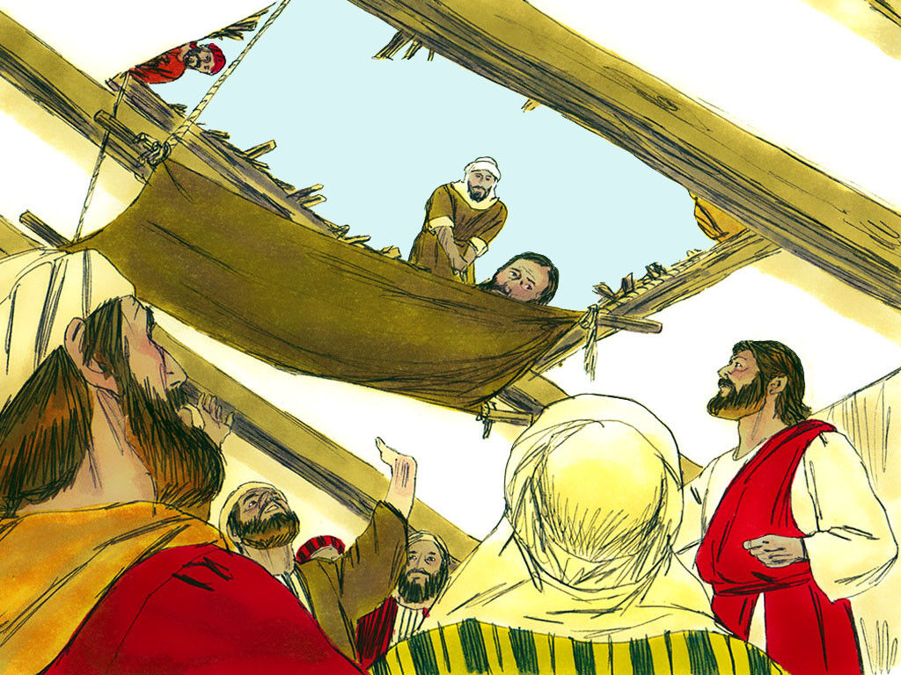 | Jesus heals blind men – have faith  Matthew 9:27-31  I wonder why Jesus healed people.  (Matthew 9: 35 – ‘Wherever he went he demonstrated God’s power by healing every kind of disease and illness.’)  What does this tell you about Jesus? (suggestion: cared for people, showed compassion, didn’t like to see people suffering)  Share today’s story with the children, it is quite a short one, but describes how Jesus healed two blind men, who had great faith.  “Do you believe? …”  “Yes we believe!”  They both had huge faith in Jesus and knew that he would heal them.  I wonder where their faith came from.  I wonder what it means to say you have faith in someone.  What difference did Jesus make in the lives of the 2 people in the Bible passage. I wonder if he still makes this difference today.  https://www.cbmuk.org.uk/what-we-do/saving-sight/  CBM is a Christian charity which supports some of the poorest communities around the world. They train up doctors and nurses to treat those who have become blind in special clinics funded by the charity. (Explain that many of the people they help have become blind due to infections or cataracts, rather than were born blind.)  The people who started this charity had faith in God to help them raise the money and begin the work across the world. Thousands of people have been healed through their work.  Pray together for the work of CBM and ask God to continue to bless their work to support those who have become blind due to poor health or diseases. | Jesus showed compassion - praying for others.  Matthew 9:35-36  v36: When he saw the vast crowds of people, Jesus’ heart was deeply moved with compassion, because they seemed weary and helpless…  What does compassion mean? (A feeling of deep sympathy and sorrow for another who is stricken by misfortune, accompanied by a strong desire to alleviate the suffering.)  Can you give me an example of when you have been compassionate to others?  What do these verses tell you about Jesus?  These verses remind me of when I see the hundreds of homeless people who live on the streets in our towns and cities. Like Jesus, I feel deeply moved and filled with compassion. However, I do sometimes feel really hopeless and unsure how to help.  I wonder what situations fill you with compassion. I wonder if you feel a bit helpless sometimes too. I wonder what we could do to help.  Luke 5:16 – ‘But Jesus often slipped away from them and went into the wilderness to pray.’  The Bible says to bring all situations to God in prayer, sometimes this is all we can do. I wonder what things we could pray for. (Safety, food, help, shelter, medical care, love, for those who help homeless people.)    Invite the children to write post it note prayers using some of the ideas from above. Then stick the prayers around images of the homeless people throughout the world and place them in your prayer/reflection space. You could also add some thoughts about how we could help those living on our own streets. | Celebration Worship  I wonder what you have learnt about Jesus this week.  I wonder how you could follow the example he gave.  I wonder if you could thank someone in school for being like Jesus for you this week.
Week 6  Teachings of Jesus | Sermon on the Mount – Jesus’ message was counter cultural  Matthew 5:1-11  Jesus spent a lot of time talking to those who followed him about God and his Kingdom. Many of these messages went against what society tells us. (Love those who hurt you, forgive people, help those who are the marginalised in society)  https://www.youtube.com/watch?v=Ze7w3-BL3OM Watch up until 1:46  This video clip explains what the Sermon on the Mount was about – you might want to use a part of this (up to 2 mins perhaps).  https://www.youtube.com/watch?v=Sx2TWFlTDBU  This looks at the words of the Beatitudes (blessings) one by one. These are included in the first 10 verses of the Sermon on the Mount. I wonder what the word blessed means? (Beatitudes is an old word that means blessed. The Beatitudes are a list of blessings from God.)  https://www.youtube.com/watch?v=8IRuSc5-VUw The Beatitudes by Saddleback Kids. You might like to sing or listen to this song which reinforces the words of the Beatitudes.  I wonder which attitude from the Beatitudes you might need to get better at. Being humble, being peacemakers, standing up for injustice?  Reflect together on this for a while, then ask God to help you to develop a good attitude to life and others. | Salt and light – Shine from the inside out    Matthew 5: 13-16  You might like to start  today’s worship with  this quote from The  Twits by Roald Dahl.  I wonder what you think  about this quote.  This quote links really well to our Bible passage today, it might help us understand it.  Read Matthew 5:13-16 together. You might want to illustrate v15 – why would you light a lamp and then hide it? Discuss the words together.  The Bible says … YOU are the salt. YOU are the light. I wonder why Jesus said these things.  How can we be salt and light? What does this mean for us all?  Jesus wants his followers to shine out, so that everyone will see the good they do and praise God because of it. Christians care for others to follow the example of Jesus and because of the love God has shown to them.  ‘We love each other because he loved us first.’ 1 John 4:19  I wonder how you could be salt and light in the world. Matthew 5:13-16 (The Message translation) might help with understanding.    https://www.youtube.com/watch?v=W2xc-w8Zcbo ‘Shine from inside out’ You might like to sing or listen to this song together. | Knock and the door shall be opened  Matthew 7: 7-11  https://www.youtube.com/watch?v=nEeJQQ3SkRA  You might like to play this sound clip of people knocking on doors.  Why do people knock on a door? Sometimes it is to deliver something, say hello or ask for something. I wonder who has knocked at your door recently?  Today’s passage also comes from the Sermon on the Mount.    ‘Ask, and you will receive; seek, and you will find; knock, and the door will be opened to you. ⁸ For everyone who asks will receive, and anyone who seeks will find, and the door will be opened to those who knock.’  I wonder what this passage might teach Christians about God. I wonder what this passage might say to you.  The passage is Jesus telling his followers to ask God, seek God and knock on the door.  Illustrate vs9-11. God only gives good gifts, not things to harm us or that we don’t need.  I wonder what you would like to knock and ask for. Discuss that God provides for what we need not what we might want! (focus on help, wisdom, guidance, healing, provision of food etc rather than material items)  Play the door knocking clip again and ask the children to be quiet and think about the things they would like to ask God for.  Close in prayer together asking God to hear the prayers of all those who have asked. | Jesus welcomes the children - be like the children  Matthew 19: 13- 15  https://www.youtube.com/watch?v=GxHHZd4Xn5Y You might like to watch this Haribo advert.  In today’s Bible passage, Jesus says to be like children. I wonder what you think this means.  Read today’s passage to the children – what did Jesus do?  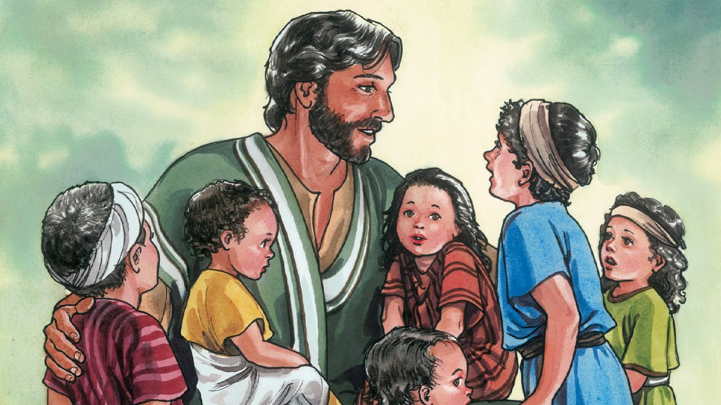  I wonder what this passage tells you about how Jesus feels about children.  Jesus valued everyone, especially children.  James 4:3 Don’t let anyone look down on you because you are young, but set an example for the believers in speech, in conduct, in love, in faith and in purity.  Encourage the children with this verse – encourage each of them to be an example to everyone no matter what their age or position.  Encourage each class to pray for another class in the school.  Dear God, bless each young person in our schools. Help each one to know that they are loved, valued and cherished by you. Amen. | Celebration Worship  Reflect – I wonder what how we should respect and care for others.  Acknowledge those who have done this in school recently.

