Fresh Approach Collective Worship Planning
Year 2 Term 6

Week 1 | Easter to Ascension to Pentecost
Week 2 | The first Christians – how Jesus’ friends spread his message
Week 3 | The first Christians – One Body
Week 4 | The first Christians – Keep Going
Week 5 | The first Christians – Caring for each other
Week 6 | The first Christians – All equal
Week 7 | Celebrating our Leavers


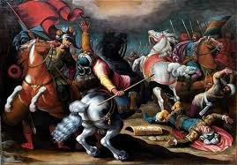
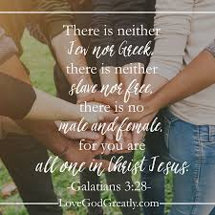
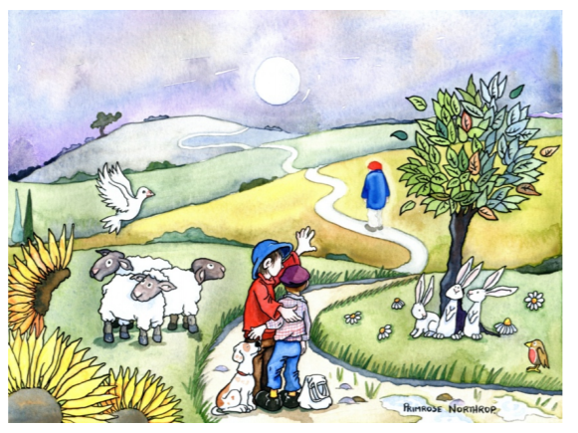
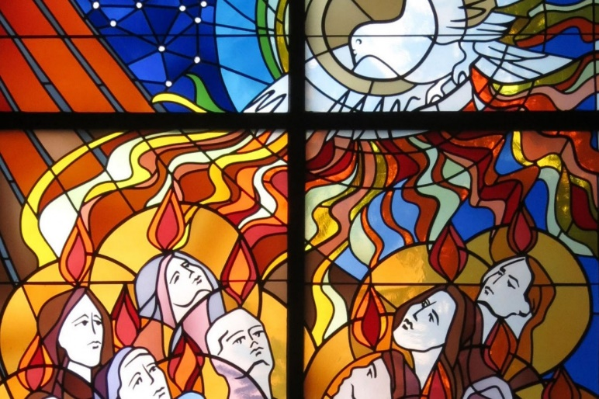
Over the course of this term, we are thinking about the events from Pentecost onwards as the followers of Jesus obeyed his command to go and make disciples of all nations (Matthew 28:19-20). Once the Holy Spirit had given power and courage to those who were the first believers in Jesus, they were inspired to go out and tell everyone who would listen about the Gospel message. This put them at risk but they did not shrink back from the mission that they were given.
We look at some of the encouragements and advice given by St Paul in the letters which he wrote for the early churches founded by the first Christians. We continue to learn much from what he wrote as we face similar challenges.
In the words of St Paul:
The grace of the Lord Jesus Christ, the love of God, and the fellowship of the Holy Spirit be with you all. AMEN
(II Corinthians 13:14)

Liturgical colour | Monday | Tuesday | Wednesday | Thursday | Friday
Week 1 | JESUS BESIDE US  Luke 24:13-32  In order to try and help children to understand how Easter and Pentecost fit together, we will look back and then forwards. Even though there is a journey from Easter to Ascension to Pentecost of just 50 days, getting a sense of the timeline is important.  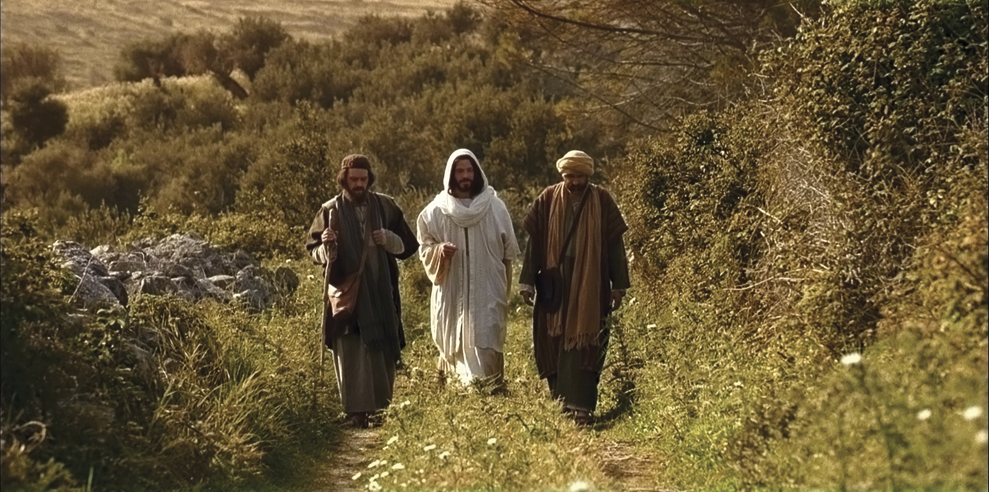  There are lots of images online of ‘The Road to Emmaus’. Find an image or draw your own of Jesus coming beside two of his followers and walking with them. Read an appropriate version of the story.  On The Emmaus Road is a simple animation  I wonder who has been walking alongside you recently. I wonder if you have felt that you needed a special friend at various points ‘on the journey’.  The two followers were so joyful when they recognised Jesus. I wonder if you are joyful when you spend time with others who are important in your life rather than simply taking family and friends for granted. | JESUS BEFORE US  John 21:4-13  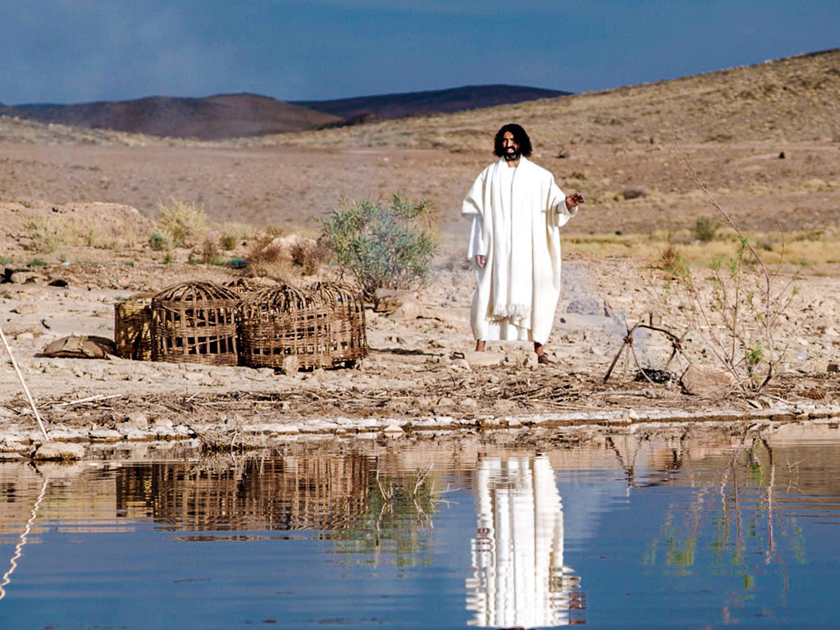  Use images to read the story or a simple retelling such as  The Miraculous Catch of fish  The disciples were Jesus’ closest friends and this episode happened when they were still unsure of what was going to happen to them in the future. Perhaps they did not recognise Jesus because they were not expecting to see him just then.  I wonder what they thought when the man on the shore told them to cast their net again after a whole night with no fish at all. I wonder what they felt when the catch came in. I wonder if you would have done what Peter did.  No matter what happens, the Bible tells us that Jesus is there before his people, encouraging them and finding ways to help as he did that morning - with the catch of fish and then by having a meal ready for them!  Christ Before Us is a traditional song for quiet reflection | JESUS AHEAD OF US  Acts 1:9-11  This is the account of Jesus saying goodbye to his disciples and returning to be with God the Father. This material may need sensitive handling, appropriate to age and context especially if anyone in the community has experienced the death of a someone close to them.  Tell the story of the Ascension in an appropriate way and then use this image to think about saying goodbye  This is an image from p42 of  Journeying with and alongside those who are grieving  which we have recommended to you as support material for grief and loss.  You might ask:  I wonder how the characters might be feeling. I wonder what you would say to the people in the front of the picture. I wonder why there might be a path in the picture. I wonder what this picture might teach us about people who are grieving.  Dear God,  Thank you for the lives of all those loved ones who, whilst no longer walking beside us or holding our hand along life’s journey  as once they did, live on in our hearts and our memories. of those they have left behind. Thank you for all that they will always mean to us. Amen. | JESUS DOES NOT LEAVE US  Acts 2: 1-15  Use an appropriate image of Pentecost. I wonder what you can see in the picture. I wonder what might be happening.  Read the account in an appropriate version or watch this animation The Holy Spirit Comes (Day of Pentecost) (from beginning to 2 mins)  This is an account of how Jesus’ disciples began to spread the good news (Gospel) to the whole world, the news that the Holy Spirit can comfort and strengthen those in need. I wonder if we could spend some time naming some of the countries that we know and praying that the people there will be safe and well. I wonder if there are situations that need our special prayers at this time.  Spirit of God (The Skye Boat Hymn) is a song about the Holy Spirit to a traditional tune | Celebrate  Those in your school community and local community who walk  - Beside us  - Before us  - Ahead of us  Thank you, God, for surrounding me with people who always look out for me. You have given me family and friends who bless me every day with kind words and actions. Bless them and bless us as we go out into our day. Amen
Week 2 | COURAGEOUS FRIENDS  Acts 2:1-11  After the day of Pentecost, the Holy Spirit gave the first disciples and followers of Jesus, the strength and the courage to go out into the world and make a difference. By telling others about Jesus and his Gospel message, they believed that the world would be a transformed place.  I wonder what these first disciples and followers would have needed to tell others so that they would believe in Jesus and follow him too.  People who are Christians believe that Jesus is completely like us – human – but also that Jesus is God’s son, and therefore completely like God himself. Completely God…..and completely human: now that’s a mystery! You might want to think about this as we look at the events of his life….in a very special story. This is a way of looking at Jesus’ life – use this clip  2 Born among us  or use similar objects are images to explore these ideas.  The message of who Jesus is and why he was born, lived, died and rose again is the Good News which the first Christians shared and which Christians still share today.  In our school, ‘May we bring peace.’  In our homes, ‘May we bring peace.’  In our relationships, ‘May we bring peace.’  In our world, ‘May we bring peace.’ | FAITHFUL FRIENDS  Matthew 4, Mark 1-3, Luke 5-6  Think of some pairs of best friends for a quiz – show one person, guess, reveal the other  Eg Winnie the Pooh and…  Buzz Lightyear and…  Nemo and…….  Etc  I wonder what makes these friendships and our own close friendships so important  This clip (from the beginning up to 3:10) highlights how varied was the group of Jesus’ first followers and how they went on to do amazing things after his death  God's Story: Jesus Calls Disciples  Use this clip or tell one of the individual stories of the call of the first disciples  I wonder how it felt to be chosen by Jesus.  I wonder what we can learn about friendship from this story.  I wonder if our friendships can also change lives.  A song about friends  Being a friend  Dear God  Thank you for our friends and how they make our lives happier.  Help us to find small ways to show our friends how much we appreciate them.  Help us we pray. AMEN | INSPIRED FRIENDS  Acts 3:1-16  Think back to the friends that Jesus chose. Think about how they changed from ordinary people following their teacher to a frightened and uncertain group of people after the events of Easter to those who went out and ‘shouted’ about Jesus. After Pentecost, they suddenly wanted to tell the whole world about their friend Jesus and how believing in Jesus could change their lives.  Just after Pentecost, Peter and John healed a man unable to walk since he was born  At The Beautiful Gate  or  https://www.freebibleimages.org/illustrations/lame-beggar-healed/  I wonder how this helped people who had never met Jesus know more about what he was like and how God had worked through him.  I wonder how we can show our joy and praise today as the man who was healed was able to do.  ‘Walking and jumping and praising God’ (Acts 3:8)  Every Move I Make | WHAT SORT OF A FRIEND WILL I BE?  John 15:16-17  The first friends of Jesus were the first people to go out and spread the good news to others. Then these people became friends of Jesus too and spread the good news. That is why there are now so many Christians across the world who are still sharing the Gospel.  “Being a friend is the best thing you can be….”  Reflect on the story of how Jesus chose 12 people to be his special friends. I wonder why he chose ordinary people, just like us. I wonder who he might have chosen if he was walking around our town/village today.  Reflect on friendship:  Write the name of a friend/s on a paper person or paper chain of people. Think about what makes them special and why you are friends with them….  ….as you put your paper person/people on the tray, you might like to pray for your friends and ask God to bless them….    …now go and be the best friend you can be... | Celebrate  Those across the whole school community who have shown their friendship in different ways during the week.  Dear God, Thank you for our friends. Thank you that you bless us with family and friends all around us. Thank you for giving us people to talk to and laugh with. We pray for all our friends today, that you will bless them and that they have a good day.  AMEN  
Week 3 | ENEMY OR FRIEND?  Acts 9:1-18  Although people listened to what Jesus’ followers were saying and joined them, it was not safe to be a Christian as they had enemies who searched them out to punish them. They were imprisoned and sometimes killed. One of the people who hunted for Christians was called Saul. He really hated those who believed in Jesus but, one day, all that changed.  Tell the story of the conversion of Saul  The Conversion of Saul  or  PAUL BECOMES A CHRISTIAN  I wonder what plans God had for Saul who changed his name to Paul. I wonder why Paul was not afraid that someone would arrest and punish him.  One of the ways in which Paul spread the Gospel was by writing letters to new churches which started to grow around the Mediterranean to help them to stay strong and faithful to Jesus. | YOU ARE THE BODY OF CHRIST  I Corinthians 12:15-27  For the next few weeks, we are looking at some of the advice which St Paul gave to the first followers of Jesus in the early churches around the Mediterranean in the letters which he wrote to them and which are part of the New Testament.  This week we are looking at what St Paul wrote to the community of Christians at Corinth. Paul wrote his letters to the early churches when he could not be with them, usually because he had heard that there was a problem and he wanted to help/make sure that they understood how they should be living out the good news of Jesus.  Now you are the body of Christ and each one of you is a part of it (I Corin 12:27)  I wonder why someone would write this in a letter. I wonder what might have happened which meant that people needed to be encouraged to act together like different parts of the same body. I wonder if something might have gone wrong in the community at Corinth.  Now look at this explanation of the broader passage about being the Body of Christ  1 Corinthians 12 12-27 BIBLE STORIES FOR KIDS | Mr Potato Head | One Body Many Parts  Use the clip or demonstrate using your own Mr Potato Head or similar.  Dear God, help me to speak and act in ways that build up the whole body of our school today. Thank you for all those around me who will support me as I try to do this for you. AMEN | WE CAN BE ONE BODY  I Corinthians 12:15-21  The Church: One Body With Many Parts  This relates to the Church but can be compared to the way in which all our gifts and talents are needed within our school community.  Draw an outline of the school and put within it suggestions from the children as to who makes the school function well from day to day, adults and pupils. I wonder what happens when somebody cannot come into school. I wonder what difference that makes. I wonder if you realise that we all miss any person who is not in school as their unique contribution is missing.  Read I Corinthians 12:14-21 again  Think about the diversity of the body of the school and take time to celebrate that and to shift the focus from what we ‘get’ to what we ‘offer’. | THANK YOU FOR OTHERS IN THE ONE BODY  I Corinthians 12:26  Involve staff and pupils in this activity to start a discussion. wonder where I fit. I wonder why I cannot get along just fine all on my own.  You need pens and a piece of wallpaper lining paper the length of a person. Nominate an adult (ask them first with a view to the actual activity – see below) to lie on the paper and to draw around their body. Then write down all over the body the names of the jobs of their family members e.g. ‘Shop worker’, ‘Fireman’, ‘Receptionist’, ‘being a Mum’, ‘Policeman’, ‘teacher’ etc. Write down as many as you can, and then discuss and draw connecting lines between the jobs that work together e.g. Policeman and fireman. Then discuss how the pupils have links with these people.  I wonder how this helps us to understand our local, national and global communities better. I wonder if the world would be a better place if we all acted as one body.  Dear God, Thank you that I am loved and supported by so many different people in my life. Help me to use this as an example to be the best part of whatever body I am a part of – in school, at home and in my wider community. AMEN | Celebrate  Those people who have supported you community well in order that it works just like a single body.  Reflect on being connected together as a community:  1. GIVE THANKS ... for communities that you are part of (for example a family, a scout pack, a tutor group)  2. ASK FOR HELP … to understand your special and unique part to play in your school community  3. REFLECT … on your day as part of the school community. What did you bring to that community and how were you blessed?  4. SAY SORRY … for the times you may have had a poor attitude toward those in the community you do not like or understand  5. DECIDE … an action you will take tomorrow to uplift the most vulnerable in your community  Thank you to Faith at Home for ideas this week
Week 4 | YOU CAN DO IT  II Corinthians 11:30  The first Christians did not choose to follow Jesus because it was an easy option and because they received some sort of immediate material reward. It was quite the opposite in fact.  From the pages of the Bible, we know that Paul went through a huge number of trials! He was beaten… shipwrecked three times… spent a night and a day in the sea… was in danger multiple times… had sleepless nights… been hungry and thirsty… cold with not enough clothes… worried for the new churches (from 2 Corinthians 11:24-27). Find some images of these incidents and discuss  https://www.freebibleimages.org/  I wonder what enabled Paul to keep getting back up again even when everything appeared to be against him.  Read the Bible verse. It was his confidence that God was in control and knew what was going on. Paul’s place of weakness and dependence upon God was actually a place of great strength. I wonder where we get our strength. I wonder if we need to look in different places for this.  You Raise Me Up  Dear God, thank you that you know my every thought, every dream and even the desires of my heart. I ask that you help me to grow in resilience and to bounce back from the things that I find difficult. AMEN | YOU CAN DO ANYTHING  Philippians 4:13  Read the Bible verse - even in difficult circumstances (see yesterday), I wonder how Paul was able to believe this.  Resilient people don’t let their troubles define them, nor do they ignore them – they grow through them. There are many definitions for resilience because it means different things to different people. Google will tell you that resilience is “the capacity to recover quickly from difficulties” or having a personal “toughness”. Other people will explain that resilience is an ability to deal with life in spite of fears, setbacks, or limited resources. Christians believe that by giving over their concerns to Jesus, he is able to extend grace to them so that they have help in our times of need. Interestingly, Jesus never promised that life would always be straightforward or without complications. In fact, he told us that, from time to time, we would face tough seasons. However, he also reminds us that he will be with us and is ready to help if we turn to him. I wonder if you can remember times when Jesus faced tough challenges and how he overcame them.  https://www.freebibleimages.org/  This song expresses how Christians keep trusting in God even in tough times  Trust in You - Lauren Daigle (Lyrics)  I wonder what challenges you might be facing this week that require resilience. Perhaps these can be shared by adults and by pupils in the community so that there is an understanding that tough challenges face us all.  If you do this, be sensitive to what pupils might share. | THE RACE OF YOUR LIFE  Hebrews 12: 1-2  In the letter to the Hebrews (which Paul may but probably did not write), we find another set of advice for the early Christians. The author writes - Imagine athletes wanting to go in for a big race. Although they might be talented, they still have to train hard. They will find some things difficult, and they will get it wrong many times before they get it right. There will be many times they will feel like giving up, but they keep on trying. This quality is called resilience.  You could use this example or similar to show a resilient runner giving everything right up to the end  The Best Race Comeback You Will Ever See  The letter encourages us to “run the race that is laid out in front of us”. Like any athlete, we will sometimes find this tough, and there will be times when we may feel like giving up. However, we are not alone in our challenges – in Jesus, as well as in many other Biblical examples, we have an example to follow, of someone who kept going, even when everything seemed lost, and in doing so, did more than they could hope for or dream. | NEVER GIVE UP  Hebrews 12:1-2  Think back to the image of a running race and never giving up. This can be really hard if you do not win a single race in many attempts. Even people we see in the bible who did amazing things were knocked down multiple times, and took the decision to get up again, growing in their resilience, their faith in God and in their capacity to face trials each time. Even the apostle Paul, the greatest missionary and church planter ever known, didn’t mind admitting that he was weak and found his ability to get up again only in God.  Watch this short video Are Crows the Ultimate Problem Solvers? To see a crow working out how to get to the food. I wonder what challenges the bird faced. I wonder how and why he demonstrated resilience.  Reflect on these words of Nelson Mandela  ‘Do not judge me by my success, judge me by how many times I fell down and got back up again’ (Nelson Mandela)  Loving God, You are with us always. Thank you for being with me in the joyful things in my life. Help me to remember you when I face challenges in my life, and to know that I do not face them alone. AMEN. | Celebrate  Those in your school community who have shown resilience in the face of challenges this week.  Reflect  How has your week / day been?  What are the things that brought you happiness?  What are the challenges you are facing right now?  Are there ways you might want to show resilience? Who will help you with this?  
Week 5 | EVERYONE NEEDS COMPASSION  2 Corinthians 1:3-7  Present this/read this out as a letter  Dear friends in Corinth  ³ Praise be to the God and Father of our Lord Jesus Christ. God is the Father who is full of mercy. And he is the God of all comfort. ⁴ He comforts us every time we have trouble, so that we can comfort others when they have trouble. We can comfort them with the same comfort that God gives us. ⁵ We share in the many sufferings of Christ. In the same way, much comfort comes to us through Christ. ⁶ If we have troubles, it is for your comfort and salvation. If we have comfort, then you also have comfort. This helps you to accept patiently the same sufferings that we have. ⁷ Our hope for you is strong. We know that you share in our sufferings. So we know that you also share in the comfort we receive.  From your good friend and Christian brother, Paul  I wonder what might have been happening to the people who received this letter. I wonder why they needed comfort. I wonder what you would do or say if someone needed your help. I wonder how important Paul’s letters were to his friends in the early Christian communities.  Reflect on the words of this song and think about what compassion might mean as we will be thinking more about this during the coming week  Compassion Hymn lyrics | ACTIONS NOT JUST WORDS  James 2:15-16  Another letter writer in the New Testament is by James – he encourages the early Christians to think about how that can be true to what they have learned in Christ. This suggests that some Christians may not have been doing this.  Christians believe the Bible teaches that God is a God of compassion, that God feels the suffering of people, that God’s compassion is expressed in his mercy, his kindness, patience, grace, forgiveness and love. Many Christians believe they are called to be a compassionate people. Compassion encompasses both a gut level feeling of sympathy and conviction as well as positive action taken on our part to relieve the suffering we observe.  Christian charities and organisations such as CAFOD see need across our world and respond with compassion – action which improves the lives of others. Here are some ideas for helping pupils to understand how they have been working across the world:  Water resources for primary schools  A Christian song for reflection  Everyone Needs Compassion  Dear God, thank you for allowing us to understand the difficulties that other people face. Show us the ways in which we can help them to overcome their challenges in life so that nobody feels alone, because together we can use your strength to help one another. Amen. | ACTIONS NOT JUST WORDS  James 2:15-16  I wonder how sympathy is different to compassion. This might help:  Sympathy looks in and says, "I'm sorry”. Compassion goes in and says, "I’m with you.”. Sympathy looks in and says, "I would like to help”. Compassion goes in and says, "I am here to help”. Sympathy says, "I wish I could carry your burden”. Compassion says "Cast your burden on me”. Sympathy often irritates with many words. Compassion helps and hears in quietness and understanding. (Author Unknown)  I wonder how we could have compassion for those in our own country who might not feel as if they really belong:  Refugee resources for children  You might set up a prayer space with a focus on refugees  Refugee Rucksacks  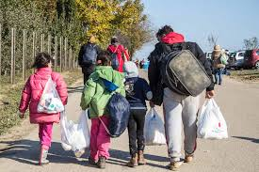  In your context, be sensitive to those who might be personally affected. | ACTIONS NOT JUST WORDS  James 2:15-16  The Prayer of St Teresa of Avila – this is a very ancient prayer which could be used as a point of reflection. Consider the words and why they might inspire a Christian to show love and care for their global neighbour and how they might inspire you to do the same:  Christ has no body now on earth but yours; no hands but yours; no feet but yours. Yours are the eyes through which the compassion of Christ must look out on the world. Yours are the feet with which He is to go about doing good. Yours are the hands with which He is to bless His people.  Christian Aid shows compassion across the world and helps us to understand that compassion is not just about helping but it’s about challenging the situations and policies that cause people to suffer.  Here is a choice of activities and ideas to explore this at an age appropriate level:  Hands Across The World  with PowerPoint slides here:  Hands Across The World assembly presentation | Celebrate  Those who have shown compassion in your school community this week  Reflect    Display the image on your screen and draw children’s attention to the word ‘action’. I wonder what actions have demonstrated your compassion this week. Go out from this place with compassion in your heart, and the desire to act it out.
Week 6 | DIFFERENT BUT EQUAL  Galatians 3:28  In his letter to the early church in Galatia, St Paul writes  “Now, in Christ, there is no difference between Jew and Greek. There is no difference between slaves and free men. There is no difference between male and female. You are all the same in Christ Jesus”.  I wonder what might have been happening in this Christian community to mean that this letter was needed (you will need to explain the cultural context of the time). I wonder whether there might be people who are not treated equally today. I wonder if Paul might have written the same thing but using different groups today.  The Bible tells us that, through God, all people can flourish; it is available to all people. The Bible also suggests that we flourish most when we are helping others and, as such, there are many Christian charities that work to enable others to flourish. We learnt about some of these charities last week.  Think about how your school community. I wonder how the people in your school are similar to each other. I wonder how they are different. I wonder how you make sure that everyone is treated equally and with dignity and respect. | DIFFERENT BUT EQUAL  Acts 10  There are a number of examples in accounts of the early church where the first followers of Jesus had to overcome their prejudices.  Use the account in the Bible passage - you will need to simplify and explain the culture of the time to make key points:  Choose someone to be Peter who should sit in the middle of the circle of children and then lie down and pretend to sleep. On the signal of a clap from the leader, he/she should wake up still dreaming and indicate by rubbing his stomach that he’s/she’s very hungry. Now invite some other members of the circle to come over to him/her and suggest some unusual, exotic foods to eat. Each time Peter should say, ‘I couldn’t possibly eat that’. At this point the whole of the circle should chorus to Peter the following words: ‘But Peter, God made all these foods and says they’re OK’. After that, the teacher should stamp on the floor to imitate the banging on a door and announce that visitors have arrived asking Peter to visit their master’s house. Peter should then say, ‘I couldn’t possibly meet him’ At this point the whole of the circle should chorus to Peter the following words: ‘But Peter, God made all these people and says they’re OK’.  Or use PETER TELLS CORNELIUS ABOUT JESUS  I wonder why Peter was unwilling to accept that he could eat the animals in the dream. I wonder why the dream came 3 times.  I wonder why Jews and Romans did not mix.  I wonder how worried Peter was about meeting Cornelius and how he overcame his worries.  I wonder if we sometimes have the wrong sorts of ideas and attitudes about people who seem to be different from us.  I wonder how we can change these ideas and attitudes. | DIFFERENT BUT EQUAL  Acts 11:16-40  Paul visited Philippi on his missionary journeys – we see that he did not just find ‘safe’ people but he interacted with anyone that God led him to and made a difference in their lives. Some props are suggested.  Purple cloth – use this to introduce Lydia – a successful businesswoman in the textile industry. God opened up her heart to hear about Jesus and she opened up her home to welcome Paul and Silas.  Crystal ball – use this to introduce the slave girl, who had the gift of seeing the future. God broke into her life so that all she could talk about was how Paul and Silas had come to bring good news. This annoyed her owners who had the two men put in prison.  Chain – use this to introduce the jailer, who watched over Paul and Silas that night. God broke into this situation too and not only rattled the chains free but shook the whole prison. In fear, the jailor turned to Paul and Silas, who had been singing about Jesus all night, asking how he too could be saved.  Images https://www.freebibleimages.org/  I wonder why Paul did not only spend time with people who were like him and who would have accepted and welcomed him. I wonder what Paul’s words and actions in Philippi can teach us. | CHANGING WHAT WE SAY AND DO  Acts 10:34  Set the scene using this or a similar example as appropriate:  The children decide to play five-a-side football. Two leaders should quickly emerge who will then choose others for their respective teams. The rest all clamour to be picked first but one person is always being pushed aside and whenever he or she speaks up, there are cries of: ‘Don’t pick him he’s useless’; ‘She’s no-good’; ‘He can’t play to save his life’; ‘People like him/her will only be a drag on the team’; ‘He’s new so we don’t want him’; ‘We don’t want her to play with us’ etc. This one will always remain unpicked and eventually is left alone. There is a pause when this happens and then he or she says ‘But what about me?’ The others say, ‘Come on, we can play without him/her. We will take turns in being a referee, so we will only play four aside instead’. They then leave and the person who wasn’t picked is alone on stage. A teacher comes on with a big smile and congratulates the one that is left, saying: ‘We have just got all your information through from your old school, Dean/Sharon. They are very sad to lose you, particularly from the football team. You were their star player, weren’t you?’  I wonder why the children wouldn’t pick Dean/Sharon.  I wonder if we’ve ever done something similar.  I wonder how our Bible verse helps us to have the right attitude towards everyone we meet.  Now I am certain that God treats all people alike. God is pleased with everyone who worships him and does what is right, no matter what nation they come from. | Celebrate  The diversity in your school community and local community as appropriate to context  Dear God  Give us the patience to build on what unites us, to celebrate our differences and to learn from them. Help us see that you created us in your image. Neighbour or stranger, always our brother or sister.  Amen.
Week 7 | CELEBRATING OUR VALUES  II Corinthians 13:14  This week the focus is on those who are leaving the school at the end of term. There are a series of activities which you would invite leavers to complete before worship and then share as part of each act of worship this week. You could split the leavers into groups so each person is involved at some point over the week.  You could build up a display over the course of the week reflecting the various elements explored each day.  Use the words of the ‘The Grace’ (from Paul’s letter above) each day to bless each other.  Many schools have 6 values, so fold A3 paper into 6, which is also like a folded map. If the school has more, you could use both sides of the paper. If the school has less the pupils could draw several examples of that value in action. Our school values help us to know how to live well together they are a bit like a map showing us where to go. Open out your paper; you will see six rectangles made by the folds. In each of these rectangles write one of our school values. You could draw a symbol for that value or a picture of someone living out that value if you wish. Fold your values map back up and write your school’s name and your name on the front. Maps often have a photograph of a place on the front, you could draw your school on the front of your map.  For the act of worship, ask some leavers to share how they think the values on their ‘map’ will help them as they move on. | CELEBRATING THE ‘WOWS’  II Corinthians 13:14  This activity gives the pupils the opportunity to celebrate the special moments they have enjoyed in the school that they are leaving - the ‘wow’ moments.  These flags of multi-coloured bunting can be used in the act of worship on washing line or bunting tape to display.  Each leaver will need two triangles of coloured paper and two pegs, and writing materials.  Think back over your time at this school. Can you think of two events that you did that were wow moments - something that you especially enjoyed or are proud of? Write or draw these moments on your flags then decorate the flag with bright colours.    For the act of worship, display the bunting and ask some leavers to share how they will treasure their ‘wow’ moments as they move on. | BEING THANKFUL  II Corinthians 13:14  This activity offers the chance to say thank you for people who have helped them while they have been at the school. It is helpful if some of the adults have learned how to make these pipe cleaner people.  Each leaver will need: Pens, small square of paper, a couple of chenille sticks / pipe cleaners per pupil, big dish. Ask pupils to think of someone they are thankful for who helped them while they have been at the school. Write their name and the reason they are saying thank you for them onto a square of paper. Now put your paper into the big dish as a symbol of thanking God for them. Finally create a pipe cleaner person to represent that person you are thankful for.    For the act of worship, present the people and the messages as a form of thank you prayer. Some pupils could speak about their person and how they helped. Pupils could then say thank you to that person later. | BEING HOPEFUL  II Corinthians 13:14  This activity looks forward to new adventures at their new school, and to have a sense of excitement and anticipation about this move.  Each leaver will need: Pens and a blank train ticket  Train Tickets For Leavers Activities  Next to the word ‘From’ write the name of the school you are leaving. Next to the word ‘To’ write the name of your new school. On the back, write or draw things you are looking forward to when you arrive at your new school.  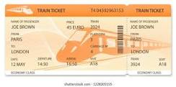  For the act of worship, display the train tickets and ask some leavers to talk about what they are looking forward to at their new school. | Celebrate  Numbers 6:24-26  with your special end of year service  Two sung versions of Aaron’s Blessing  The Lord Bless You and Keep You  The Lord bless you and keep you  May the grace of our Lord Jesus Christ, and the love of God, and the fellowship of the Holy Spirit be with us all, now and evermore. Amen.  Thank you to Guildford Diocese for these ideas  Leavers' Service Resources for use in Schools or Churches

