Rowan Class – Optional Spring Homework Grid
HISTORY  - Research Stone Age tools. Choose one tool and create a fact file explaining what it was made from and how it was used. | GEOGRAPHY  Research how Stone Age people used natural resources (stone, wood, water). Present your findings as a labelled diagram or short explanation. | ENGLISH  Write a short Stone Age story based on an adventure such as a hunt, a storm, or discovering fire. | Your homework is due on these Mondays:  26/1  9/2  HALF TERM  2/3  16/3  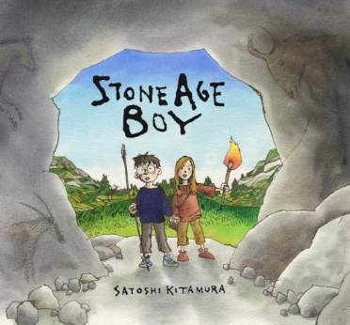
HISTORY  Create a timeline showing the different periods of the Stone Age (Palaeolithic, Mesolithic, Neolithic). Add pictures and short descriptions for each period. | GEOGRAPHY  Research how the climate was different during the Stone Age. Present your findings in pictures and short sentences. | ENGLISH  Write a Stone Age information page. Include headings, pictures, and facts about daily life, homes, food, and tools.
ART  Create a piece of Stone Age cave art using natural colours. You may draw, paint, or use charcoal or chalk. | SCIENCE  Research how Stone Age people discovered and used fire. Present your work as a diagram or short explanation. | COOKING  Design a Stone Age–inspired meal using ingredients that would have been available then. Draw and label your meal (no cooking required unless supervised).
ART  Create a Stone Age necklace or pattern design inspired by natural materials such as stones, bones, or shells. | DESIGN AND TECHNOLOGY  Build a Stone Age shelter using recycled or natural materials (e.g. cardboard, sticks, leaves). | ACTIVE BODY AND MIND  Create a poster showing how Stone Age people stayed active (hunting, gathering, walking). Add modern activities you do to stay healthy.
ALL HOMEWORK SHOULD BE COMPLETED NEATLY USING APPROPRIATE WRITING TOOLS.

