Research and write a diary or news report about a Viking raid. Include what happened and how people felt. | Draw a map showing where Vikings came from and where they settled in Britain. Add labels and a key. | Design and make a Viking shield using paper or cardboard. Use bold patterns.
Create a fact file about Anglo-Saxons or Vikings (homes, food, clothing, jobs). | Solve: 5 ships × 8 warriors. = Now, create your own Viking maths problems. Try to create 5, using different mathematical operations. | Make simple flatbread like Anglo-Saxons would have eaten.
Research the beliefs of Vikings and create a poster about their Gods. | Imagine you are a Viking going on a long journey across the sea.  - Draw or list 5 things you would pack  - Explain why you chose each item  - Think about food, warmth, and tools | Draw your own small Anglo-Saxon village.  - Include houses, paths, and something to protect it (like a fence or wall)  - Label key parts  - Think about what people need to live there (water, food, shelter)
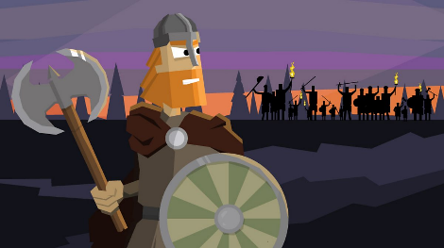
Anglo-Saxon and Viking Struggle for Power Topic Grid – Summer Term

